Table of Contents

I.

II.

III.

IV.

V.

VI.

Introduction…………………………………………………….....…1

Safety Precautions…………………………………………………...2

Storage and Installation……………………………………………..4

Standards and Specifications……………………………………….5

Wiring……………………………………………………………..…8

Instruction of the Digital Operator……………………………….14

VII. Commissioning……………………………………………………..19

VIII. Function List………………………………………………………..20

IX.

X.

XI.

Descriptions of Functions………………………………………….27

Care & Maintenance, Fault Information and Troubleshooting..66

Selection of Peripheral Devices and Disposition………………....72

XII. Appendices…………………………………………………………76

This Instruction Manual is subject to changes due to product upgrading. No further notice
will be given.

I. Introduction
Thank you for purchasing and using the RLP series multi-function and high performance
inverter.
Please read carefully the operation manual before putting the inverter to use, so as to
correctly install and operate the inverter, give full play to its functions and ensure the
safety. Please keep the operation manual handy for future reference, maintenance,
inspection and repair.
In case of any problems that can not be solved during your use of our product, please
contact our local distributors at any time or contact with our company directly. Since the
inverter is a kind of electrical and electronic product, it must be installed, tested and
adjusted with parameters by specialized engineering persons of motors. The marks of

and other symbols in the manual remind you of the safety and
prevention cautions during the handling, installation, running and inspection. Please
follow these instructions to make sure the safe use of the inverter. In case of any doubt,
please contact our local agent for consultation. Our professional persons are willing and
ready to serve you.
The manual is subject to change without notice.

II. Safety Precautions
The RLP series multi-function and high performance inverter has been strictly and well
packed before ex-work. After your purchase, please examine the product package to see
whether any components are lost during the transportation, and whether the product
specifications and models comply with the machine you purchased before the unpacking.
Contact the supplier in case of any problem.
2.1 Examination after unpacking
1. The machine is provided with an instruction manual and a warranty card.
2. Examine the nameplate on the inverter side to confirm it is the product you
purchased.
2.2 Safety precautions
Danger indicates wrong use may kill or injure people.

Caution indicates wrong use may damage the inverter or mechanical system.

Note: The grades of caution will probably lead to severe results due to different
conditions. Please follow the notes, as they are very important for personal safety.

Danger

●
●

●
●

●
●
●
Be sure to turn off the input power supply before wiring.
Do not touch any internal electrical circuit or component when the charging lamp
is still on after the AC power supply is disconnected, which means the inverter
still has high voltage inside and it is very dangerous.
Do not check components and signals on the circuit boards during the operation.
Do not dissemble or modify any internal connecting cord, wiring or component
of the inverter by yourself.
Do not operate the switch button with wet hand, so as to prevent electrical shock.
Be sure to make correct ground connection of the earth terminal of the inverter.
Never remodel it or exchange control boards and components by yourself. It may
expose you to an electrical shock or explosion, etc.
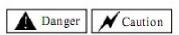

Caution

●

●

●

●

●

●

●
●

●
Do not make any voltage-withstanding test with any component inside the
inverter. These semi-conductor parts are subject to the damage of high voltage.
Never connect the AC main circuit power supply to the output terminals U.V W
of the inverter.
The inverter and the braking resistor are under high temperature when the power
supply is connected or soon after it is disconnected, do not touch them, so as to
prevent burning.
Voltage imposed on all terminals should conform to the voltage indicated in the
instruction manual, so as to prevent explosion or damage.
The main electric circuit boards of CMOS and IC of the inverter are subject to
the effect and damage of static electricity. Don't touch the main circuit boards.
Installation, testing and maintenance must be performed by qualified
professional personnel.
The inverter should be discarded as industrial waste. It is forbidden to burn it.
Please examine and commission the inverter prior to use if it is saved for long
time.
Setting for high speed operation of the inverter can be made easily. Before the

setting is changed, examine whether the motor and its mechanical performances
are suitable for high speed running.

2.3 Precautions during transportation and storage
Caution

●

●

●

●
●

●

●

●

●

●

●
Do not carry the front cover of the inverter directly when handling. It should be
handled with the base to prevent the fall-off of the front cover and avoid the
dropping of the inverter, which may possibly cause the injuries to people and the
damages to the inverter.
Mount the inverter on a metal or other noncombustible material to avoid the risk
of fire.
Install the inverter in a safe location, avoiding high temperature, direct sunlight,
humid air or water.
Keep the inverter from the reach of children or persons not concerned.
The inverter can only be used at the places accredited by our company. Any
unauthorized working environment may have the risks of fire, gas explosion,
electric shock and other incidents.
Install a heat sink or other cooling device when installing more than one inverter
in the same enclosure, so that the temperature inside the enclosure be kept below
40°C to avoid overheat or the risk of fire.
Be sure to turn off the power supply before dissembling or assembling the
operation key panel and fixing the front cover to avoid bad contact causing faults
or non-display of the operator.
Do not install the inverter in a space with explosive gas to avoid the risk of
explosion.
If the inverter is used at or above 1,000m above seal level, the cooling efficiency
will be worse, so please run it by de-rating.
Do not install any contactor and other components of capacitor or varistor on the
output side of the inverter. Otherwise it will cause malfunctions and damages of
components of the inverter.
Do not install any switch component like air circuit breaker or contactor at the
output of the inverter. If any of such components must be installed because of the

requirements of process and others, it must be ensured that the inverter has no
output when the switch acts. In addition, it is forbidden to install any capacitor
for improvement of power factor, or any varistor against thunder at the output.
Otherwise it will cause malfunctions, tripping protection and damages of
components of the inverter. Please remove them as shown in the below diagram.

●

●
It will affect the service life of the inverter if a contact is connected to the front
end of input of the inverter to control its starts and stops. Generally it is required
to control it through FOR or REV terminals. Special attention should be paid to
its use in the case of frequent starts and stops.
Please use an independent power supply for the inverter. Do avoid using the

common power supply with an electrical welder and other equipment with strong
disturbance. Otherwise it will cause the protection or even damage of the
inverter.
Before the Power-up

●
Check to make sure that the voltage of the main circuit AC power supply matches the
input voltage of the inverter.

The symbol

represents ground terminals. Be sure to make correct ground

connection of the earth terminals of the motor and the inverter for safety.

●
No contactor should be installed between the power supply and the inverter to be

used for starting or stopping of the inverter. Otherwise it will affect the service life of
the inverter.
During the Power-up

●
Do not plug the connectors of the inverter during the power up to avoid any

surge into the main control board due to plugging, which might cause the
damage of the inverter. Always have the protective cover in place before the
power up to avoid electrical shock injury.
During the Operation

●

●

●

●
Never connect or disconnect the motor set while the inverter is in running.
Otherwise it will cause over-current trip and even burn up the main circuit of the
inverter.
Never remove the front cover of the inverter while the inverter is powered up to
avoid any injury of electric shock.
Do not come close to the machine when the fault restart function is used to avoid
anything unexpected. The motor may automatically restart after its stop.
The function of STOP Switch is only valid after setting, which is different from

the use of emergent stop switch. Please pay attention to it when using it.

III. Storage and Installation
1. Storage
● It must be stored in a dry place without rubbish or dust.
● The suitable temperature for storage is between -20℃ and +65 ℃.
● The relative humidity required is 0-95% without condensation.
● There is no corrosive gas or liquid in the storage ambience.
● It's better to lay the inverter on a rack and keep it in a proper package.
● It is better not to store the inverter for long time. Long time storage of the
inverter will lead to the deterioration of electrolytic capacity. If it needs to be
stored for a long time, make sure to power it up one time within a year and the
power-up time should be at least five hours. When powered up, the voltage must
be increased slowly with a voltage regulator to the rated voltage value.
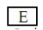

2. Installation Site and Environment
● Ambient temperature -5℃ to 40℃ with good ventilation.
● Free from the interference of electromagnetic noise.
● No water drop, stream, dust, cotton, and metallic particles.
● Free from oil, salt or corrosive gas.
● Free from vibration.
● Free from high temperature and large humidity, no rainfall, humidity <90% (no
condensation).
● Prohibited from use in inflammable, humid and explosive liquid or solid places.
Attention: The ambient conditions of the inverter will affect its service life.
3. Installation Space and Direction
● There must be enough space left around the inverter for easy maintenance and
cooling. See Diagram.
● The inverter must be installed vertically with the smooth ventilation for effective
cooling.
● If there is any instability when installing the inverter, please put a flat board
under the inverter bottom base and install it again. If the inverter is installed on a
loose surface, stress may cause damage of parts in the main circuit, so as to
damage the inverter.
● The inverter should be installed on non-combustible materials, such as iron
plate.
● If several inverters are installed, upper and lower, together in one cabinet, please
add heat dissipation plates and leave enough space between the inverters.

IV. Standards and Specifications
1. Specifications
Type | Input Voltage | Power  (KW) | Inverter  Capacity  (KVA) | Output  Current (A) | Suitable  (Motor)
RLPM10 00D423A | One & Three Phase  220V 50Hz | 0.4 | 1.0 | 2.5 | 0.4
RLPM10 00D7523A | One & Three Phase  220V 50Hz | 0.75 | 2.0 | 5.0 | 0.75
RLPM10 01D523A | One & Three Phase  220V 50Hz | 1.5 | 2.8 | 7.0 | 1.5
RLPM10 00D443A | 3Φ380V 50Hz | 0.4 | 1.2 | 1.2 | 0.4
RLPM10 00D7543A | 3Φ380V 50Hz | 0.75 | 2.2 | 2.7 | 0.75
RLPM10 01D543A | 3Φ380V 50Hz | 1.5 | 3.2 | 4.0 | 1.5

RLPB1 0 03D743A | 3Φ380V 50Hz | 3.7 | 6.8 | 8.5 | 3.7
RLPB1 0 05D543A | 3Φ380V 50Hz | 5.5 | 10 | 12.5 | 5.5
RLPB1 0 07D543A | 3Φ380V 50Hz | 7.5 | 14 | 17.5 | 7.5
RLPB1 0 001143A | 3Φ380V 50Hz | 11 | 19 | 24 | 11
RLPB1 0 001543A | 3Φ380V 50Hz | 15 | 26 | 33 | 15
RLPB1 0 18D543A | 3Φ380V 50Hz | 18.5 | 32 | 40 | 18.5
RLPB1 0 002243A | 3Φ380V 50Hz | 22 | 37 | 47 | 22
RLPB1 0 003043A | 3Φ380V 50Hz | 30 | 52 | 65 | 30
RLPB1 0 003743A | 3Φ380V 50Hz | 37 | 64 | 80 | 37
RLPB1 0 004543A | 3Φ380V 50Hz | 45 | 72 | 91 | 45
RLPB1 0 005543A | 3Φ380V 50Hz | 55 | 84 | 110 | 55

RLPA 10 01D543A | 3Φ380V 50Hz | 1.5 | 3.2 | 4.0 | 1.5
RLPA 10 02D243A | 3Φ380V 50Hz | 2.2 | 4.0 | 5.0 | 2.2
RLPA 10 03D743A | 3Φ380V 50Hz | 3.7 | 6.8 | 8.5 | 3.7
RLPA 10 05D543A | 3Φ380V 50Hz | 5.5 | 10 | 12.5 | 5.5
RLPA 10 07D543A | 3Φ380V 50Hz | 7.5 | 14 | 17.5 | 7.5
RLPA10 001143A | 3Φ380V 50Hz | 11 | 19 | 24 | 11
RLPA 10 001543A | 3Φ380V 50Hz | 15 | 26 | 33 | 15
RLPA 10 18D543A | 3Φ380V 50Hz | 18.5 | 32 | 40 | 18.5
RLPA 10 002243A | 3Φ380V 50Hz | 22 | 37 | 47 | 22
RLPA 10 003043A | 3Φ380V 50Hz | 30 | 52 | 65 | 30
RLPA 10 003743A | 3Φ380V 50Hz | 37 | 64 | 80 | 37
RLPA 10 004543A | 3Φ380V 50Hz | 45 | 72 | 91 | 45
RLPA 10 005543A | 3Φ380V 50Hz | 55 | 84 | 110 | 55
RLPA 10 007543A | 3Φ380V 50Hz | 75 | 116 | 152 | 75
RLPA 10 009043A | 3Φ380V 50Hz | 90 | 134 | 176 | 90
RLPA 10 011043A | 3Φ380V 50Hz | 110 | 160 | 210 | 110
RLPA 10 013243A | 3Φ380V 50Hz | 132 | 193 | 253 | 132
RLPA 10 016043A | 3Φ380V 50Hz | 160 | 230 | 304 | 160
RLPA 10 018543A | 3Φ380V 50Hz | 185 | 260 | 340 | 185
RLPA 10 020043A | 3Φ380V 50Hz | 200 | 290 | 380 | 200
RLPA 10 022043A | 3Φ380V 50Hz | 220 | 325 | 426 | 220
RLPA 10 025043A | 3Φ380V 50Hz | 250 | 481 | 480 | 250
RLPA 10 028043A | 3Φ380V 50Hz | 280 | 427 | 560 | 280
RLPA 10 030043A | 3Φ380V 50Hz | 300 | 450 | 580 | 300
RLPA 10 031543A | 3Φ380V 50Hz | 315 | 460 | 605 | 315
RLPA 10 034543A | 3Φ380V 50Hz | 345 | 502 | 660 | 345
RLPA 10 037543A | 3Φ380V 50Hz | 375 | 544 | 715 | 375
RLPA 10 040043A | 3Φ380V 50Hz | 400 | 582 | 765 | 400
RLPA 10 041543A | 3Φ380V 50Hz | 415 | 604 | 795 | 415

Type | Input Voltage | Power  (KW) | Inverter  Capacity  (KVA) | Output  Current (A) | Suitable  (Motor)
RLPA10 00D423A | One & Three Phase  220V 50Hz | 0.4 | 1.0 | 2.5 | 0.4
RLPA 10 00D7523A | One & Three Phase  220V 50Hz | 0.75 | 2.0 | 5.0 | 0.75
RLPA 10 01D523A | One & Three Phase  220V 50Hz | 1.5 | 2.8 | 7.0 | 1.5
RLPA 10 02D223A | One & Three Phase  220V 50Hz | 2.2 | 4.4 | 11 | 2.2
RLPA 10 03D723A | One & Three Phase  220V 50Hz | 3.7 | 6.8 | 17 | 3.7
RLPA 10 00D443A | 3Φ380V 50Hz | 0.4 | 1.2 | 1.2 | 0.4
RLPA 10 00D7543A | 3Φ380V 50Hz | 0.75 | 2.2 | 2.7 | 0.75

2. General Specifications
Inverter Series |  | RLP Series
Control Mode |  | SPWM
Input Power |  | 380V Power supply: 380±15% 220V Power supply:  220±15%
5-Digits Display & Status  Indicator Lamp |  | Displaying frequency, current, revolution, voltage, counter,  temperature, forward or reserve running, and fault, etc.
Communication Control |  | RS-485
Operation Temperature |  | -10~40℃
Humidity |  | 0-95% Relative Humidity (without dew)
Vibration |  | Below 0.5G
 | Range | 0.10~400.00Hz
 | Accuracy | Digital: 0.01% (-10-40℃) ; Analog: 0.1% (25±10℃)
 | Setting Resolution | Digital: 0.01Hz; Analog: 1%o of Max. Operating Frequency
 | Output Resolution | 0.01Hz
 | Keyboard Setting Method | Press directly to set
 | Analog Setting Method | External Voltage 0-5V, 0-10V, 4-20mA,0-20mA
 | Other Functions | Frequency lower limit, starting frequency, stopping frequency,  three skip frequencies can be respectively set.
 | Ramp Control | Selectable 4-speed steps ramp-up and down time (0.1-6500s).
 | V/F Curve | Set V/F curve at will
 | Torque Control | Torque increase is settable by max. 10.0%. The starting torque  can reach 150% at 1.0Hz.
 | Multi-Inputs | 6 multi-function input terminals for 8-speed steps control,  program operation, switching of 4-speed Ramp, UP/DOWN  function, counter, external emergency stop and other functions.
 | Multi-Outputs | 5 multi-function output terminals for displaying of running, zero  speed, counter, external abnormity, program operation and other  information and warnings.
 | Other Functions | AV R (auto voltage regulation), Deceleration stop or free-stop,  DC brake, auto reset and restart, frequency track, PLC control,  traverse function, drawing control, auto energy-savings, carrier  adjustable by max. 16KHz, etc.
 | Overload Protection | Electronic relay protection motor  Drive (for constant torque 150%/1 min; for the kinds of fan  120%/1min.)
 | FUSE Protection | FUSE broken, motor stops.
 | Over-voltage | DC Voltage > 400V for 220V class  DC Voltage > 800V for 380V class
 | Low Voltage | DC Voltage < 200V for 220V class  DC Voltage < 400V for 380V class
 | Instant Stop and Restart | Restarted by frequency track after instantaneous stop.
 | Stall Prevention | Anti-stall during Acc/Dec run
 | Output End Shorts | Electronic circuit protecting
 | Other Functions | Fin over-heat protection, restriction of reverse running, direct  start after power on, fault reset, parameter lock PID,  one-drive-more, etc.

Frequency Control
General Control
Protection
Functions

V. Wiring
（1）Introduction of Wiring Terminals

（2）Arrangement of Main Circuit Terminals
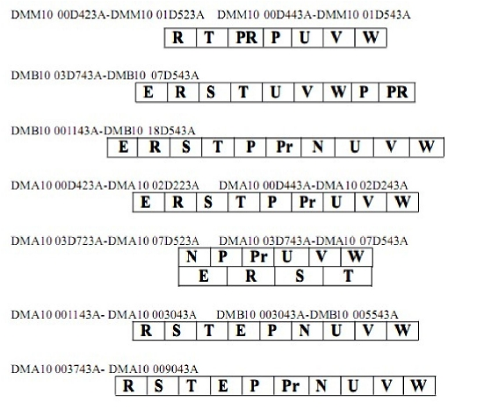

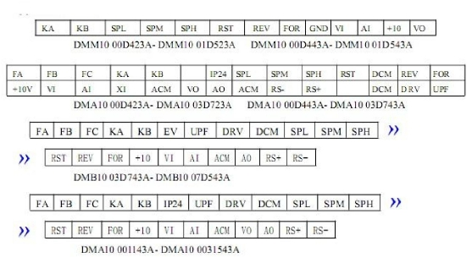

（3）Introduction of RLPA and RLPB Series Main Circuit Terminals

(4) Introduction of RLPA and RLPB Series Control Terminals
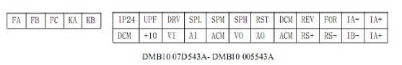

Symbol | Function Description | Factory Setting
FOR | Multi-Input 1 | Forward run
REV | Multi-Input 2 | Reverse run
RST | Multi-Input 3 | Reset
SPH | Multi-Input 4 | High speed
SPM | Multi-Input 5 | Middle Speed
SPL | Multi-Input 6 | Low Speed
DCM | Common Terminal of Digital and Control  Signals, IP 24 Power Ground
EV (IPV) | +12V Power Supply | Max. output current 200mA
IP24 | +24V Power Supply | Max. output current 200mA
+10 | Power Supply for Speed Setting | +10V
VI | Analog Voltage Frequency Command | 0—+10V corresponding  to the highest operating
AI | Analog Current Frequency Command | 4~20mA corresponding to the  highest operating frequency
XI | Analog Input
AO | Output Current
VO | Output voltage
ACM | Common Terminal of Analog and Control
DRV | Multi-Output 1 (Optical couple output) | DC24V/100mA
UPF | Multi-Output 2 (Optical couple output) | DC24V/100mA
FA  FB  FC | Multi-Output 3 (N/O or N/C) | 3A/250VAC, 3A/30VDC
RS+ RS- | RS485 Communication port

Symbol | Function Description
R.S.T | Input terminal of AC line power. (220V class, for both single/three  phase, single phase connected to any two phases)
U.V.W | Output terminal of the inverter
P.Pr | Connector for braking resistor.
P, N | Connecting terminal of external braking bank.
E | Ground terminal: the third method of grounding for 220V and  special grounding for 380 V of Electrical Engineering  Regulations.

(5) Introduction of RLPM Series Main Circuit Terminals

(6) Introduction of RLPM Series Control Terminals

Nameplate Description of HLP Series Inverter

Symbol | Function Description | Factory Setting
FOR | Multi-Input 1 | Forward run
REV(D2) | Multi-Input 2 | Reverse run
RST(D3) | Multi-Input 3 | Reset
SPH(D4) | Multi-Input 4 | High speed
SPM(D5) | Multi-Input 5 | Middle Speed
SPL(D6) | Multi-Input 6 | Low Speed
GND | Common Terminal of Digital and Control  Signals, IP 24 Power Ground
+10 | Power Supply for Speed Setting | +10V
VI | Analog Voltage Frequency Command | 0—+10V corresponding to the  highest operating
AI | Analog Current Frequency Command | 4~20mA corresponding to the  highest operating frequency
VO | Output voltage
KA  KB | Multi-Output 3 (N/O or N/C) | 3A/250VAC, 3A/30VDC

Symbol | Function Description
R.S.T | Input terminal of AC line power. (220V class, for both single/three  phase, single phase connected to any two phases)
U.V.W | Output terminal of the inverter
P.Pr | Connector for braking resistor.

(5) Basic Connection Diagram
The wiring of the inverter is divided into two parts, main circuit terminal connections
and control circuit terminal connections. The user can see the main circuit terminals
and the control circuit terminals after removing the cover of enclosure. The terminals
must be connected correctly as the following wiring circuit diagrams.
The following diagram shows the factory standard connection of RLP series.

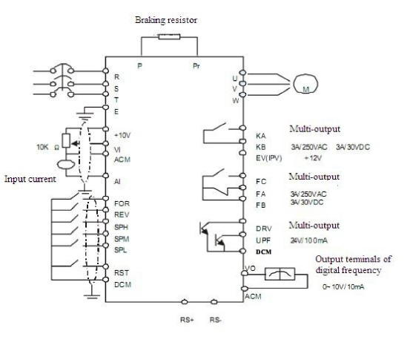

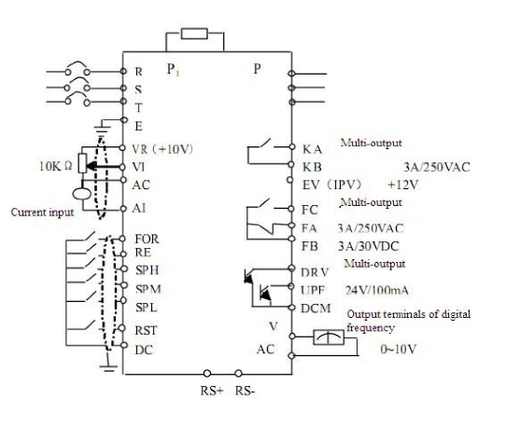

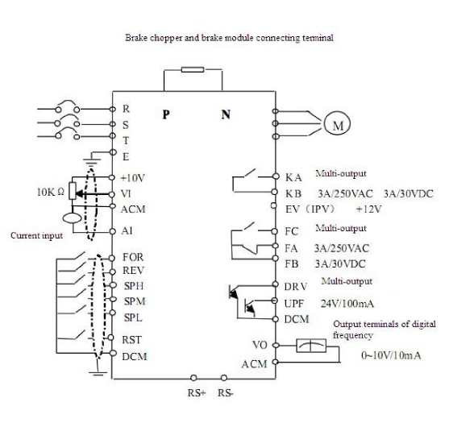

(6) Precautions on Wiring
1) For the main circuit wiring:

●

●

●

●
●

●

●
●

●
While wiring, the sizes and specifications of wires should be selected and the
wiring should be executed according to the electrical engineering regulations to
ensure the safety.
It is better to use shielded wire or wire and conduit for power cord and ground the
shielded layer or two ends of wire conduit.
Be sure to install a Non Fuse Breaker (NFB) between the power supply and the
input terminals (R.S.T). (If using ground fault circuit interrupter, please choose
one corresponding to high frequency).
Never connect AC power to the output terminal (U.V.W) of the inverter.
Output wires mustn't be in touch of the metal part of the inverter enclosure, or it
will result in earth short-circuit.
Phase-shifting capacitors, LC, RC noise filters, etc, can never be connected to the
output terminals of the inverter.
The main circuit wire must be enough far away from other control equipments.
When the wiring between the inverter and the motor exceeds 15 meters for 220V
class or 30 meters for 380V class, much higher dV/dT will be produced inside the
coil of the motor, which will cause the destruction to the interlay or insulation of
the motor. Please use a dedicated AC motor for the inverter or add a reactor at the
inverter.
Please lower the carrier frequency when there is a longer distance between the
inverter and the motor. Because the higher the carrier frequency is the bigger the
leakage current of high-order harmonics in the cables will be. The leakage current
will have unfavorable effect on the inverter and other equipment.

VI. Instruction of the Digital Operator

Introduction of RLPA Series Digital Operator

Introduction of RLPM Series Digital Operator
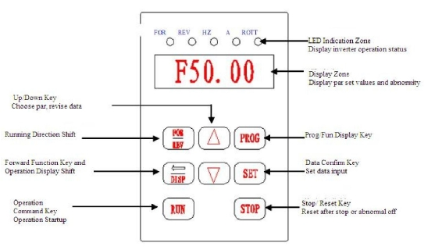

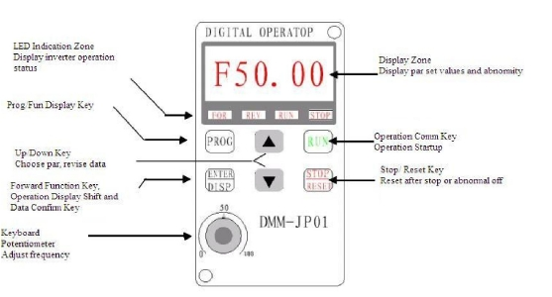

Introduction of RLPB Series Digital Operator (3.7KW-7.5KW)

Introduction of RLPB Series Digital Operator (11KW-18.5KW)
2. Indicator Lamps
1) Description of RLPA and RLPB Series Indicator Lamp Status
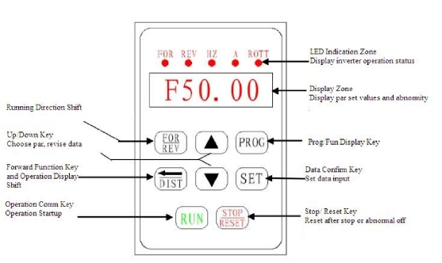

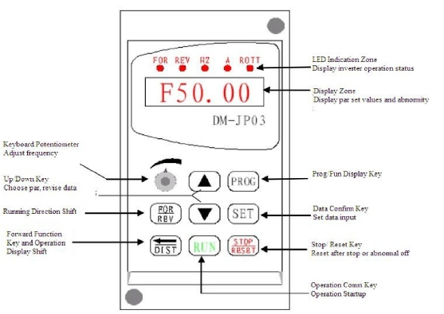

Indicator lamp | Status | Description
FOR | on | The motor is in forward rotation.
REV | on | The motor is in reverse rotation.
HZ | on | Displaying set frequency or output
A | on | Displaying output current.

2) Description of RLPM Series Indicator Lamp Status

3) Description of RLPM Series Display Items

4) Description of RLPA and RLPB Series Display Items
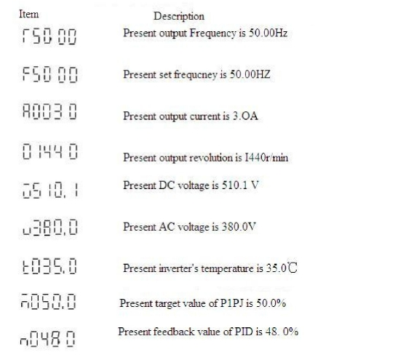

Indicator lamp | Status | Description
FOR RUN | on | The motor is in forward rotation.
REV RUN | on | The motor is in reverse rotation.
FOR STOP | on | The motor is stopped.
REV STOP | on | The motor is stopped.

ROTT | on | Displaying rated motor revolution
A ROTT | on | Displaying AC or DC voltage.
HZ ROTT | on | Displaying counting value.
HZ A ROTT | on | Displaying internal temperature of the

5) Description of RLPA and RLPB Series Digital Operation
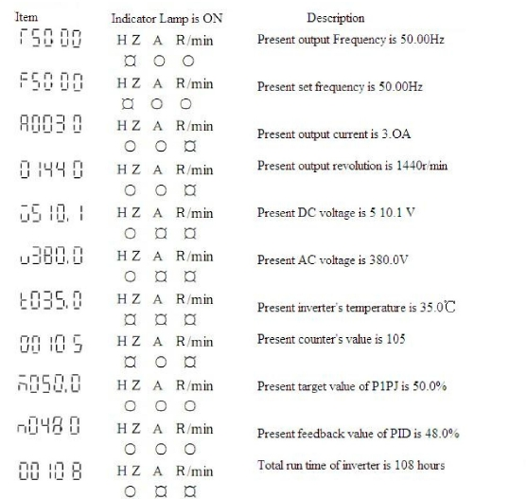

Procedures | Display | Indicator Lamp | Explanation
Power up,  Operation of power |  |  | Self detect when  power-up, display version  no. (Flashing) and finally  set frequency.
PROG | PD000 |  | Enter programming  Display the function of  PD000
SET | 000.00 |  | Display the contents of  PD000
 | 50.00  END-50.00  PD000  050.00 |  | Change the content of  PD000  Confirm changed value.  Display END 50.00  PD001  Black from programming.

Note: (1)

means flashing;

means bright;

(2) For monitoring AC, DC, F and other items, they can be only switched and
displayed after the parameter setting;
(3) When it is powered up again after a power breakdown, the inverter will
display the screen previous to the power breakdown after its self-detection.

 | 50.00 |  | Display running and  operating frequency
Display running and
operating frequency
 | A005.0 |  | Monitor screen switching,  display output current
 | 01440 |  | Monitor screen switching,  display rotation speed
Switch back to main
screen, display set
frequency
Switch of For./Rev.
rotation, display the status
of Rev rotation
 | 050.00 |  | Switch to adjustable  frequency
 | 030.00 |  | Adjust set frequency, i.e.  the value of PD000
 | 030.00 |  | Determine the changed  value, input to PD003
 |  |  | Stop

VII. Commissioning

1.
●

●

●
●

Important Checks before the Commissioning
If there is any wrong with connected wires, pay special attention to the terminal
of U.V.W. (Make sure the power supply wires are connected to R.S.T.)
If there is any metal powder or wires left on the base plate of the inverter or the
terminal block, which may cause short circuit.
If screws are tightly locked and if the connecting parts are loose.
If there is any short circuit or earth fault at outputs.

2. Commissioning Methods
The procedure of the operator is factory set up for the control mode of RLP series.
The commissioning can be carried out through the digital operator.
Generally, the commissioning can be conducted at 5.00 Hz.
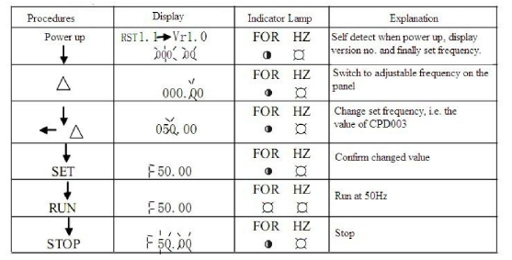

VIII. Function List

Parameter and Function List (Part 1)

Category
Code
Function
Set Range & Function Explanation Factory Setting

PD000

Parameter Lock

0: Invalid; 1: Valid

0

PD001
Control Method
0.
Operator
0

1.
External terminal

PD002

Selection of Frequency
2.
Communication port

0

Basic
Parameters
Setting
1. External terminal
2. Communication port
3. Operator potentiometer

PD003
Main Frequency
0.01~400.00 Hz
*

PD004
PD005
Base Frequency 0.01~400.00 Hz
Max Operating Frequency 10.00~400.00Hz
50.00
50.00

PD006
PD007
PD008
PD009
PD010
PD011
PD012

PD013

PD014
PD015
PD016
PD017
PD018
PD019
PD020
PD021
PD022
Intermediate Frequency
Min. Frequency
Max. Voltage
Intermediate Voltage
Min. Voltage
Frequency Lower
Reserved

Parameter Reset

Accel. Time 1
Decel. Time 1
Accel. Time 2
Decel. Time 2
Accel. Time 3
Decel. Time 3
Accel. Time 4
Decel. Time 4
Reserved
0.01~400.00 Hz
0.01~20.00Hz
0.1V-*
0.1V-*
0.1V-50.0V
0.00~400.00 Hz

8 Restore the factory setting.

0.1~6500.0S
0.1~6500.0S
0.1~6500.0S
0.1~6500.0S
0.1~6500.0S
0.1~6500.0S
0.1~6500.0S
0.1~6500.0S
2.50/3.00
0.50
220/380
*
*
0

00

*
*
*
*
*
*
*
*

PD023

PD024

PD025
Inverse Rotation
Allowed

Invalid Stop Key

Starting Mode
not 0: Inverse rotation not allowed
1: Inverse rotation allowed
0: STOP invalid
1: STOP valid
0: Start from Starting Frequency
1: Frequency track start
1

1

0

Applicable
Parameters

PD026

PD027
PD028
PD029

Stopping Mode

Startup Frequency
Stop Frequency
Startup Brake Time
0: Decelerating stop
1: Coasting stop
0.1~10.0Hz
0.1~10.0Hz
0~25.0

0

0.5
0.5
0.0
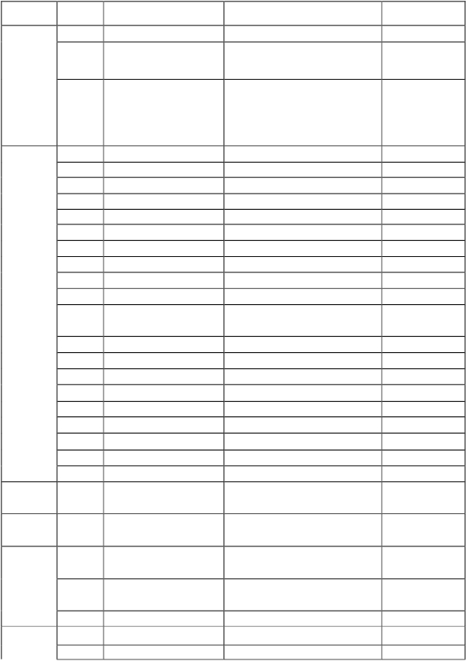

0.
Operator

PD030
PD031
PD032
PD033

Stop Brake Time
DC Brake Base
Frequency Track Time
Frequency Track Current

0~25.0
0.0~20.0%
0.1~20.0S
0.1~200.0S

0.0
2.0
5.00
150.0

Base

PD034
Voltage Rise Time of
0.1~10S
0.5

Frequency Track

PD035-
PD040
Reserved

PD041
PD042
PD043

Carrier Frequency
Jogging Frequency
S Curve Time

0~15
0.00~400.00Hz
0~6500S

*
5.00
0
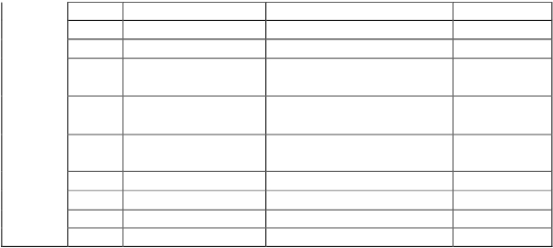

Parameter and Function List (Part 2)
Category | Code | Function | Set Range & Function Explanation | Factory Setting
Input and  Output  Terminal  s | PD044 | FOR(D1) Function | 0:Invalid; 1:Run; 2:For rotation;3: Rev rotation;4:Stop; 5:  FOR/REV.; 6:Jog; 7: Jog For rotation;8:Jog Rev Rotation;  9: External control time 1; 10: External control timer 2;11:  Reserved; 12: Overheat of heat sink or motor; 13:  Emergent stop; 14: Reset; 15~16; Reserved; 17:  Accel/Decel time select 1; 18: Accel/Decel time select2;  19: Multi-speed 1; 20: Multi-speed 2; 21: Multi-speed 3;  22: High speed; 23: Middle speed; 24: Low speed; 25: PID  Allowed; 26: Reserved; 27: Up; 28: Down; 29: Traction  allowed; 30: Reserved; 31: Pulse counter; 32: Pulse  counter reset | 02
Input and  Output  Terminal  s | PD045 | REV(D2) Function |  | 03
Input and  Output  Terminal  s | PD046 | RST(D3) Function |  | 14
Input and  Output  Terminal  s | PD047 | SPH(D4) Function |  | 22
Input and  Output  Terminal  s | PD048 | SPM(D5) Function |  | 23
Input and  Output  Terminal  s | PD049 | SPL (D6) Function |  | 24
Input and  Output  Terminal  s | PD050 | Y1 Output Function | 0: Invalid; 1: Run; 2: Zero Speed Indication; 3: Fault  indication; 4: DC Braking indication; 5:Set Frequency  reach; 6: In Accel; 7: In Decel.; 8: Arbitrary Frequency 1  reach; 9: Arbitrary Frequency 2 reach;10: Motor Overload  Alarm; 11: Over-torque Alarm; 12:Inverter Overload  Alarm; 13: Counter Reach; 14~16: Reserved; 17: Low  Voltage Alarm; 18: Internal Control Multi-speed End  Indication; 19: Internal Control Multi-speed Process End  Indication; 20~26: Reserved; 27: Traction End Indication;  28: PID Low Limit Alarm Indication; 29: PID Up Limit  Alarm Indication; 30: Reserved; 31: Braking Resistor Act;  32: Fan act indication | 01
Input and  Output  Terminal  s | PD051 | Y2 Output Function |  | 05
Input and  Output  Terminal  s | PD052 | (FA, FB and FC  Terminals) Output  Function |  | 03
Input and  Output  Terminal  s | PD053 | (KA and KB  Terminals) Output  Function |  | 00
Input and  Output  Terminal  s | PD054 | VO Output Function | Output of digital frequency signals 0-7 | 0
Input and  Output  Terminal  s | PD055 | VO Analog Output  Gain | 0.0~100.0% | 0.00
Input and  Output  Terminal  s | PD056 | Skip Frequency 1 | 0.00~400.00 | 0.00
Input and  Output  Terminal  s | PD057 | Skip Frequency 2 | 0.00~400.00 | 0.00
Input and  Output  Terminal  s | PD058 | Skip Frequency 3 | 0.00~400.00 | 0.00
Input and  Output  Terminal  s | Pd059 | Skip Frequency | 0.10~10.00Hz | 0.50
Input and  Output  Terminal  s | Pd060 | Uniform Frequency 1 | 0.00~400.00Hz | 0.1
Input and  Output  Terminal  s | Pd061 | Uniform Frequency 2 | 0.00~400.00Hz | 0.00
Input and  Output  Terminal  s | Pd062 | Uniform Frequency  Range Setting | 0.10~10.00Hz | 0.50
Input and  Output  Terminal  s | Pd063 | Timer 1 | 0.1~10.0 | 0.1
Input and  Output  Terminal  s | Pd064 | Timer 2 | 1~100 | 1
Input and  Output  Terminal  s | PD065 | Counting Value Set | 00~65500 | 00
Input and  Output  Terminal  s | PD066 | Intermediate Counter  Value | 0~65500 | 0
Input and  Output  Terminal  s | PD067-  PD069 | Reserved

Parameter and Function List (Part 3)
Category | Code | Function | Set Range & Function Explanation | Factory Setting
 | PD070 | Analog Input Select | 0: 0~10V  1: 0~5V  2: 0~20mA  3: 4~20mA  4: 0~10V, 4~20mA stacked  5: External pulse input | 0
 | PD071 | Analog Filtering Constant | 0~50 | 20
 | PD072  PD073  PD074  PD075 | Higher Analog Frequency  Lower Analog Frequency  Bias Direction at Higher Frequency  Bias Direction at Lower Frequency | 0.00~400.00 Hz  0.00~400.00 Hz  0: Positive 1: Negative  0: Positive 1: Negative | 50.00  0  0  0
 | PD076 | Analog Negative Bias Reverse:  allowable. | 0: Not Allowable  1: Allowable | 0
 | PD077 | Up/ Down Memory Function Select | 0: Not memorized  1: Memorized | 0
 | PD078 | Up/ Down Stack Select | 0: 0.01Hz  1: 0.1Hz | 0
 | PD079 | Reserved
Category | Code | Function | Set Range & Function Explanation | Factory Setting
Multi-  Speed | PD080 | Running Mode Select | 0: General running  1: Internal control 16-speed  2: External control 4-speed  3: External control 8-speed  4: Traction  5: Interference | 0
Multi-  Speed | PD081 | Internal Control Multi-speed Running  Mode Select | 0: Stop after running one cycle  1: Cycled running  2: Stop after automatic running one  cycle (Stop interval)  3: Automatic cycled running (Stop  interval) | 0
Multi-  Speed | PD082 | Internal Control Front 8-speed Running  Direction | 0~255  (0: Positive; 1: Negative) | 0
Multi-  Speed | PD083 | Internal Control Back 8-speed Running  Direction | 0~255  (0: Positive; 1: Negative) | 0
Multi-  Speed | PD084 | Internal Control Front 8-speed Accel/  Decel Time | 0~65535 | 0

 | PD085 | Internal Control Back 8-speed Accel/  Decel Time | 0~65535 | 0
 | PD086 | Frequency 2 Set | 0.00-400.00Hz | 15.00
 | PD087 | Frequency 3 Set | 0.00-400.00Hz | 20.00
 | PD088 | Frequency 4 Set | 0.00-400.00Hz | 25.00
 | PD089 | Frequency 5 Set | 0.00-400.00Hz | 30.00
 | PD090 | Frequency 6 Set | 0.00-400.00Hz | 35.00
 | PD091 | Frequency 7 Set | 0.00-400.00Hz | 40.00
 | PD092 | Frequency 8 Set | 0.00-400.00Hz | 0.50
 | PD093 | Frequency 9 Set | 0.00-400.00Hz | 10.00
 | PD094 | Frequency 10 Set | 0.00-400.00Hz | 15.00
 | PD095 | Frequency 11 Set | 0.00-400.00Hz | 20.00
 | PD096 | Frequency 12 Set | 0.00-400.00Hz | 25.00
 | PD097 | Frequency 13 Set | 0.00-400.00Hz | 30.00
 | PD098 | Frequency 14 Set | 0.00-400.00Hz | 35.00
 | PD099 | Frequency 15 Set | 0.00-400.00Hz | 40.00
 | PD100 | Frequency 16 Set | 0.00-400.00Hz | 45.00
 | PD101 | Internal Control Multi-speed Timer 1 | 0.0-6500.0S | 10.0
 | PD102 | Internal Control Multi-speed Timer 2 | 0.0-6500.0S | 10.0
 | PD103 | Internal Control Multi-speed Timer 3 | 0.0-6500.0S | 0.0
 | PD104 | Internal Control Multi-speed Timer 4 | 0.0-6500.0S | 0.0
 | PD105 | Internal Control Multi-speed Timer 5 | 0.0-6500.0S | 0.0
 | PD106 | Internal Control Multi-speed Timer 6 | 0.0-6500.0S | 0.0
 | PD107 | Internal Control Multi-speed Timer 7 | 0.0-6500.0S | 0.0
 | PD108 | Internal Control Multi-speed Timer 8 | 0.0-6500.0S | 0.0
 | PD109 | Internal Control Multi-speed Timer 9 | 0.0-6500.0S | 0.0
 | PD110 | Internal Control Multi-speed Timer 10 | 0.0-6500.0S | 0.0
 | PD111 | Internal Control Multi-speed Timer 11 | 0.0-6500.0S | 0.0
 | PD112 | Internal Control Multi-speed Timer 12 | 0.0-6500.0S | 0.0
 | PD113 | Internal Control Multi-speed Timer 13 | 0.0-6500.0S | 0.0
 | PD114 | Internal Control Multi-speed Timer 14 | 0.0-6500.0S | 0.0
 | PD115 | Internal Control Multi-speed Timer 15 | 0.0-6500.0S | 0.0
 | PD116 | Internal Control Multi-speed Timer 16 | 0.0-6500.0S | 0.0
 | PD117 | Internal Control Multi-speed Memory | 0-1 | 0

Parameter and Function List (Part 4)
Category | Code | Function | Set Range & Function Explanation | Factory Setting
 | PD118 | Over-voltage Speed-loss Select | 0-1 | 1
 | PD119 | Speed-loss Base during Accel | 0-200 | 150
 | PD120 | Speed-loss Base during Constant Speed | 0-200 | 0
 | PD121 | Speed-loss Decl Time during Constant  Speed | 0.1-25.5 | 5
 | PD122 | Speed-loss Level during Decl | 0-200 | 150
 | PD123 | Over-torque Detection Mode Select | 0-3 | 0
 | PD124 | Over-torque Detection Level | 0-200 | 0
 | PD125 | Over-torque Detection Time | 0.1-20. 0 | 1. 0
 | PD126 | Pulse Counter Memory | 0-1 | 0
 | PD127-  PD129 | Reserved
Water  Supply  Under  Constant  Pressure | PD130 | Number of Auxiliary Pump | 0-2 | 0
Water  Supply  Under  Constant  Pressure | PD131 | Continuous Operating Time of Aux.  Pumps | 1-9000min | 60
Water  Supply  Under  Constant  Pressure | PD132 | Interlocking Time of Aux. Pumps | 1-250s | 5s
Water  Supply  Under  Constant  Pressure | PD133 | High Speed Running Time | 1-250s | 60s
Water  Supply  Under  Constant  Pressure | PD134 | Low Speed Running Time | 1-250s | 60s
Water  Supply  Under  Constant  Pressure | PD135 | Stopping Voltage Level | 1-150% | 95%
Water  Supply  Under  Constant  Pressure | PD136 | Lasting Time of Stopping Voltage  Level | 1-250s | 30s
Water  Supply  Under  Constant  Pressure | PD137 | Wakeup Level | 1-150% | 80%
Water  Supply  Under  Constant  Pressure | PD138 | Sleep Frequency | 0.00-400.0 | 20. 00
Water  Supply  Under  Constant  Pressure | PD139 | Lasting Time of Sleep Frequency | 1-250s | 20s
Water  Supply  Under  Constant  Pressure | PD140 | Reserved
 | PD141 | Rated Motor Voltage  Rated Motor Current  Motor Pole No.  Rated Motor Revolution | Set upon motor nameplate | *
 | PD142 |  | Set upon motor nameplate | *
Parameter  s  of Motor  Functions | PD143 |  | 02—10 | 04
Parameter  s  of Motor  Functions | PD144 |  | 00—9999 | 1440
Parameter  s  of Motor  Functions | PD145 | Automatic Torque Compensation | 2.0-10. 0 | 2， 0
Parameter  s  of Motor  Functions | PD146 | Motor No-load Current | 0—100 | 40
 | PD147 | Motor Slip Compensation | 0. 0-100 | 0.0
 | PD148-  PD149 | Reserved
 | PD150 | AVR Function | 0-1 | 1
 | PD151 | Automatic Energy Conservation | 0-20 | 0
 | PD152 | Breakdown Restart Time  Stop Restart Select  Allowable Breakdown Time  Breakdown Restart Number | 0.2-25 | 1
 | PD153 |  | 0：Invalid; 1：Frequency track | 0
 | PD154 |  | 0. 1-5. 0s | 0. 5
 | PD155 |  | 0-10 | 00

Parameter and Function List (Part 5)
Category | Code | Function | Set Range & Function Explanation | Factory Setting
PID  Paramete  rs | PD156 | Proportional Constant | 0.0-1000.00% | 100%
PID  Paramete  rs | PD157 | Integral Time (I) | 0.1-3600.00s | 5. 0
PID  Paramete  rs | PD158 | Differential Time (D) | 0.01-10.00s | 0
PID  Paramete  rs | PD159 | Target Value | 0.0-100.00% | 0
PID  Paramete  rs | PD160 | Target Value Select | 0: Set by the operator  1: Set by external terminals | 0
PID  Paramete  rs | PD161  PD162 | PID Upper Limit  PID Lower Limit | 0~100%  0~100% | 100%  0%
Commun  ication  Function | PD163  PD164  PD165 | Communication Address  Communication Baud Rate  Communication Data Method | 0-250  0-3  0-5 | 0  1  0
 | PD166-  PD169 | Reserved
 | PD170 | Display Items | 0-5 | 0
Monitori  ng  Paramete  rs | PD171  PD172  PD173  PD174  PD175  PD176 | Display Items Open  Fault Clear  Rated Voltage of Inverter  Rated Current of Inverter  Type of Inverter  Standard of Inverter Frequency | 0-15  00- 10〔01means Fault Clear）  Set upon Model  Set upon Model  0:50Hz 1:60Hz | 0  *
Monitori  ng  Paramete  rs | PD177 | Fault Record 1 | Note:----No fault record | *
Monitori  ng  Paramete  rs | PD178 | Fault Record 2 | Note:----No fault record | ---
Monitori  ng  Paramete  rs | PD179 | Fault Record 3 | Note:----No fault record | ---
Monitori  ng  Paramete  rs | PD180 | Fault Record 4 | Note:----No fault record | ----
Monitori  ng  Paramete  rs | PD181 | Software Version No. |  | ----
Monitori  ng  Paramete  rs | PD182 | Ex-factory Date | Year Month Day | *
 | PD183 | Serial Number |  | *
 | PD184-  PD250 | Reserved

IX. Descriptions of Functions

PD000 Parameters Lock
Set Range: 0-1 Unit: 1 Factory Setting: 0
0: Invalid
1: Valid, means parameters are locked. Except for this parameter, all parameters are
not allowed to be changed.
It can prevent the wrong operations by non-professionals, thus causing unnecessary
dangers and mistakes.
It can be changed by pressing ▲ or ▼.

PD001 Control Mode Select
Set Range: 0-2 Unit: 1 Factory Setting: 0
0: Keyboard is set.
The running orders are given by the keyboard.
1: External switch input terminal programming
The running orders are given by the external terminals, which are set by 6-speed
programmable terminals.
2: Communication port is set.
The running orders are given by the communication port.

PD002 Frequency Set Select
Set Range: 0-3 Unit: 1 Factory Setting: 0
0: Keyboard set The current operation frequency is set by the keyboard Pd003.
1: Analog set The current operation frequency is controlled by the input
analog signals, whose type is decided by Pd070. Refer to
Pd070-Pd076 for related parameters.
2: Modbus set The current operation frequency is set by the communication
port.
3: Operator potentiometer set The current operation frequency is set by the
operator potentiometer.

Pd003 Main Frequency **
Set Range:0.00-400.00Hz Unit: 0.01Hz Factory Setting: 0.00
In the digital operator mode, the inverter will run at the set value of Pd003.During
running, the operating frequency can be changed by pressing ▲ or ▼. During
multi-speed running, the main frequency is taken as the frequency of speed 1.
In the external control multi-speed mode, if Pd002 is set to 1, ie. given by an external
terminal, Speed 1 will be given by the analog of the external terminal.
The setting of main frequency is limited by the maximum operating frequency.
The related parameters of Pd002, Pd080, are adjustable during operation.

Pd004 Base Frequency **
Set Range:0.01-400.00Hz Unit: 0.01Hz Factory Setting: 50.00
This parameter must be set according to the rated frequency of operating voltage on
the motor's nameplate. Under normal conditions, do not change the set value of base
frequency at will. If it is equipped with a special motor, this value should be set
properly according to the characteristics of the motor's parameters. Otherwise it may
cause the damage to the equipment.

Pd005 Max. Operating Frequency
Set Range:10.00-400.00Hz Unit: 0.01Hz Factory Setting: 50.00
This parameter determines the max operating frequency of the inverter.

Pd006 Intermediate Frequency
Set Range:0.01-400.00Hz Unit: 0.01Hz Factory Setting: 2.50
Note: ** means this parameter is adjustable during the operation.
This parameter is set for an intermediate frequency value of arbitrary V/F curve. If it
is set improperly, it will cause over-current or under-torque of the motor, or even
tripping of the inverter.
The intermediate frequency set value is restricted by the base frequency set value.

Pd007 Min. Frequency
Set Range:0.01-20.00Hz Unit: 0.01Hz Factory Setting: 0.50
This parameter decides the minimum startup frequency in the V/F curve.

Pd008 Max. Voltage
Set Range:0.1-* Unit: 0.1V Factory Setting: 220/380V
This parameter should be set according to the rated value of the motor's nameplate.
The factory setting is 380V for 380V class motor and 220V for 220V class motor. The
setting range of this parameter is restricted by the voltage rating of the inverter. In
case of the motor relatively far away from the inverter, this set value can be increased
properly.

Pd009 Intermediate Voltage
Set Range:0.1-510.0V Unit: 0.1V Factory Setting: 15/27.5
This parameter is set for an intermediate voltage value of arbitrary V/F curve. If it is
set improperly, it will cause over-current or under-torque of the motor, or even
tripping of the inverter. When the intermediate frequency is increased, the voltage will
increase the output torque and at the same time also the output current. When
changing this parameter, please pay attention to monitoring the output current to avoid
the inverter's tripping due to over-current.
The factory setting of 220V class inverter is 15 and that for 380V is 27.5.
This set value of intermediate voltage is limited by the set value of max voltage.
When the voltage is increasing to a certain value at intermediate frequency, the torque
compensation will lose its function. When adjusting this parameter, the output current

of the inverter should be increased from low to high slowly according to the load of
machines until it meets the starting requirement. Do not be quick to increase it by
large amplitude. Otherwise it might cause the tripping of the inverter or the damage of
the machines.

Pd010 Min. Voltage
Set Range:0.1-380.0V Unit: 0.1V Factory Setting: *
This parameter determines the minimum startup voltage in the V/F curve.
The factory setting is 8 for 220V class inverter and 13.5 for 380V class inverter.
The setting value of Pd010 is restricted by the voltage of maximum operating
frequency.

Pd011 Lower Limit Frequency
Set Range:0.00-400.00 Unit: 0.01Hz Factory Setting: 0.00
The lower limit frequency is set to avoid the wrong operation of site workers, thus
preventing the motor from overheating or mechanical breakdowns due to too low
frequency.
The lower limit frequency must be lower that the setting value of upper limit
frequency.
The following table is the factory setting for RLPA, RLPB and RLPM series V/F curve,
acceleration/ deceleration time, and filtering wave.
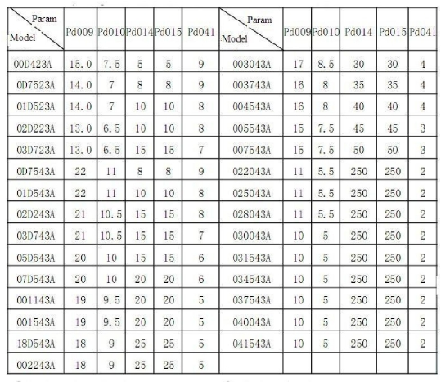

Note: ① Ramp Time 2 = Ramp Time 1 x 2
② Ramp Time 3 = Ramp Time 2 x 2
③ Ramp Time 4 = Ramp Time 3 x 2
④ Min.Voltage Value = Intermediate Voltage Value/2
⑤ The intermediate frequency is 2.5 for the system of 50Hz.
⑥ The intermediate frequency is 3.0 for the system of 60Hz.

Pd012 Reserved
The following are several curves and set values often used for reference. Specific
curves must be set according to concrete characteristics of mechanical load.

Curve of constant torque

Curve of lower torque

Curve of higher torque

Pd013 Parameter Reset
Set Range: 00-10 Unit: 1 Factory Setting: 00
When the value for a parameter is set improper or is abnormal for some reasons, this
parameter can be set to 08 to restore it to the factory setting and then reset. After the
parameters are locked (in case of Pd000=1), the parameters can't be reset. They can
only be reset after unlock. For related parameters, refer to P013.

PD014 Accel. Time 1

**

Set Range: 01—
P015 Decel. Time 1
Set Range: 01—
P016 Accel. Time 2
Set Range: 01—
P017 Decel. Time 2
Set Range: 01—
P018 Accel. Time 3
Set Range: 01—
6500.0S

6500.0S

6500.0S

6500.0S

6500.0S
Unit: 01S

Unit: 01S

Unit: 01S

Unit: 01S

Unit: 01S
Factory Setting: *
**
Factory Setting: *
**
Factory Setting: *
**
Factory Setting: *
**
Factory Setting: *
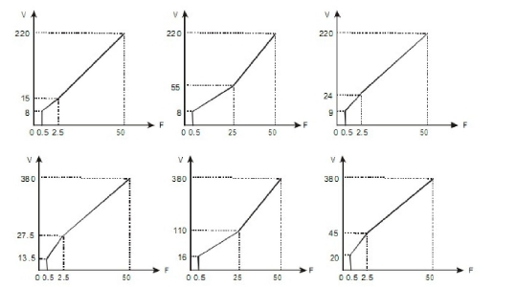

P019

Decel. Time 3

***

Set Range: 01— 6500.0S Unit: 01S Factory Setting: *
P020 Accel. Time 4 **
Set Range: 01— 6500.0S Unit: 01S Factory Setting: *
P021 Decel. Time 4 **
Set Range: 01— 6500.0S Unit: 01S Factory Setting: *
Ramp-up time means the time needed for the inverter to increase the frequency from
0Hz to the maximum operating frequency (See tl in the diagram). Ramp-down Time
means the time needed for the inverter to decrease the frequency from the maximum
operating frequency to 0Hz (See t2 in the diagram).

M Series inverter has altogether 4 Ramp Times. For Ramp Time 2.3.4, the user can
select the different ramp up or down time through the external terminals or switching
of ramp time according to the actual needs. In the internal control multi-speed
operation, different ramp time can be selected through easy PLC.
Generally the default of the inverter is Ramp Time 1, which is factory set depending
on the model. Ramp Time 4 is for the jogging ramp time. For the factory setting of
parameters refer to the table in CD006.
The related parameters: Pd044-Pd049, Pd084, Pd085

Pd022 Factory Reserved

Pd023 Rev Rotation Disable
Set Range: 0-1 Unit: 1 Factory Setting: 1
0: Rev rotation disables.
1: Rev Rotation enables.
This function is suitable for the motor, which is not allowed to rotate reversely, to
prevent workers from false operation. When the reverse rotation is disabled, the motor
can only rotate forward, not reverse.

Pd024 Stop Key Invalid
Set Range: 0-1 Unit: 1 Factory Setting: 1
0: STOP key invalid.
1: STOP key valid.
This parameter set is only valid when Pd001 is set to l or 2.

Pd025 Starting Mode

Set Range: 0-1
Unit: 1
Factory Setting: 0
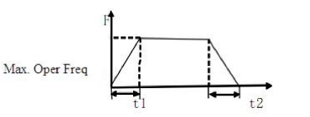

Two starting modes are available for the needs of different equipment.
0: Start from the starting frequency.
When Pd 029 is set to 0, i.e. DC braking is invalid at start, it starts running from the
starting frequency. When Pd029 is set to any non-zero value, i.e. DC braking is valid
at start, it first performs a DC braking at start, and then starts from the starting
frequency.
For the related parameters refer to Pd027, Pd029 and Pd031.
1: Start by frequency track
This setting can be used for the restarting of large inertia load. When restarting, the
inverter will trace the former frequency from the set frequency downward. In case of
large inertia equipment, when restarting, it can implement the running command and
track the former frequency right away without waiting for the complete stop of the
equipment to save time.
Note: When the inverter is restarted by frequency track, it will start tracking the
frequency from its set frequency downward, and search it at the highest speed. When
restarting, the current becomes higher, and over-current or stall may occur. So
attention must be paid to the adjustment of current level of frequency track. Generally,
Pd033 is adjusted around 100. The concrete value can be set according to the
characteristics of mechanical load.

Pd026 Stopping Mode
Set Range: 0-1 Unit: 1 Factory Setting: 0
0: Decelerating Stop
When Pd030 is set to 0, DC braking is invalid. When DC braking is invalid, the
inverter will decelerate to the stopping frequency, and then stop outputs, and the
motor will coast to stop. When CD142 is set to any non-zero value, DC braking is
valid, and the inverter will first decelerate to the stopping frequency, and then stop by
DC braking.
DC braking at stop is usually used for high position stop or for positioning control. It
must be noticed that frequent uses of DC braking will cause over-heat of the motor.
For the related parameters refer to Pd028, Pd030 and Pd031.
1: Coasting Stop
When the inverter receives a STOP command, it will immediately stop output and the
motor will coast to stop. When the coasting stop mode is selected, DC braking is
invalid.
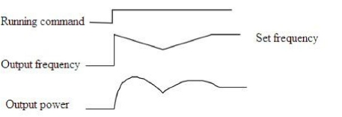

Pd027 Starting Frequency
Set Range: 0.1-10.0Hz Unit: 0.1Hz Factory Setting: 0.5
Starting frequency is the initial frequency when the inverter is started. If the starting
frequency is set to 5.0Hz, the inverter will run between 5.0 Hz and the maximum
operating frequency after its start at 5.0Hz. The actual maximum operating frequency
is limited by the upper limit of frequency.
For the related parameters, refer to Pd025, Pd029 and Pd031.

Pd028 Stopping Frequency
Set Range: 0.1-10.0Hz Unit: 0.1Hz Factory Setting: 0.5
When stopping, the inverter will decrease its frequency to the stopping frequency and
then stop running or start DC braking to stop.
If Pd029 is set to 0, DC braking is invalid at stop and the inverter will stop running. If
Pd029 is set for valid, the inverter will stop by DC braking after it reduces to the value
of Pd028.
For the related parameters, refer to Pd028, Pd029 and Pd030.

Pd029 DC Brake Time at Start

Set Range: 0.0-25.0S Unit: 0.1S
Factory Setting: 0.0

This parameter is set for DC Braking at start and the lasting time of DC Braking
current to the motor. If it is set to zero, it means DC braking is invalid.
DC braking at start is normally used in the application, in which the load is movable
when the machine is at stop, such as winRLPill. Because of the load existing before the
inverter drives, the motor is often in coasting with an uncertain rotation direction. So
the DC braking can be executed before starting the motor to prevent the inverter from
tripping.
When Pd025 is set to 0, it is valid.
For the related parameters, refer to Ph025, Ph029 and Ph031.

Pd030 DC Brake Time at Stop

Set Range: 0.0-25.0 Unit: 0.1S
Factory Setting: 0.0
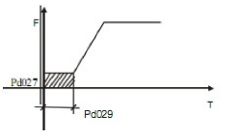

When this parameter is set to any non-zero value it starts DC brake at stop and sends
the DC braking time to the motor. DC braking at stop is often used for a high-level
stop or positioning control. When this parameter is set to zero, it closes DC braking at
stop.
This setting is valid when PD026 is set to 0.
For the related parameters, refer to Ph026, Ph028 and Ph031.

Pd031 DC Braking Voltage Level
Set Range: 0.0-20.0% Unit: 0.1% Factory Setting: 2.0
This parameter is set for the DC braking voltage to the motor at start and stop. It can
be adjusted for different braking voltage. When adjusting the parameter, it must be
increased slowly from lower value to high value, until the sufficient braking torque is
achieved.
The voltage at maximum frequency is 100% voltage.

Pd032 Frequency Track Time
Set Range: 0.0-20.0S Unit: 0.1S Factory Setting: 5.0
This parameter is set as frequency track time when the inverter is started by frequency
track after an external abnormality or temporary power breakdown. For starting or
stopping of some large inertia load, if restarting a machine after its complete stop, it
will waste much time because of its large inertia of load. But if the frequency track is
started, it is not necessary to wait for the machine to come to a full stop for restart.
The inverter will trace the frequency from high to low with the set frequency. After
searching, it will continue to accelerate to reach the set frequency.

Pd033 Current Level for Frequency Track
Set Range: 0-200% Unit: 1% Factory Setting: 150
When the inverter is tracing the frequency, this set value is taken as the level for
output current. When the output current is higher than this level, the inverter will
decrease the frequency to restore the current below the level and then it will execute
the frequency track again.

Pd034 Voltage Rise Time during Frequency Track Factory Setting: 0.5
When the starting mode of the inverter is set to frequency track, there is a process of
voltage rise during the frequency track. When the voltage is rising rapidly, the current
will be higher and the tracking process will be faster. When the voltage is rising
slowly, the current will be lower and the tracking process will be slower. In general
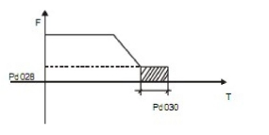

practice, this value of Pd034 is set lower for the inverter of smaller power and set
higher for the inverter of larger power.

Pd035-Pd040

Reserved

Pd041 Carrier Frequency KHz (Note: 0—15 corresponds to 0—20K Hz)
Set Range: 0-15 Unit: 1 Factory Setting: 5
The carrier frequency is related to the electromagnetic noise, as well as to the heating
capacity of the inverter and the interference of the environment. See the table as
follows:

Table of Carrier Frequency

The higher the carrier is, the lower the electromagnetic noise of the motor will be, but
the stronger its interference to other systems will be and the greater the heating
capacity of the inverter will have. Under higher ambient temperature and heavier load
of the motor, the carrier frequency should be decreased properly to improve the heat
characteristics of the inverter.
The factory setting of carrier frequency is depending on the model.

Pd042 Jogging Frequency **
Set Range: 0.0-400.00 Unit: 0.01 Factory Setting: 5.00
The parameter set can realize the jogging function when the inverter is tested. The
jogging operation can be only achieved through the external terminals, which can be
set by multi-input terminals. Jogging frequency is limited by the frequency
upper/lower limits. While the jogging function is implemented, other running
commands are invalid. The ramp-up time of jogging frequency is set by Ramp-up
Time 4. When the jog button is released, the inverter will stop output immediately. In
case of jogging function, please set the corresponding multi-input terminals to 07 or
08.
This function is only valid at stop. It is invalid at running.
For the related parameters, refer to Pd044~Pd049.
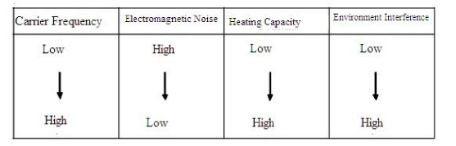

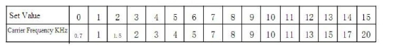

Pd043 S-Curve Time
Set Range: 0-6500S Unit: 1 Factory Setting: 1
This parameter can be set for no impact slow start or slow stop of the inverter when
starting or stopping. When starting S-curve, the inverter will make accelerating or
decelerating curve of different speed rates according to Ramp Time.

Pd044
Pd045
Pd046
Pd047
Pd048
Pd049

D1 Terminal Function
D2 Terminal Function
D3 Terminal Function
D4 Terminal Function
D5 Terminal Function
D6 Terminal Function

Factory Setting: 02
Factory Setting: 03
Factory Setting: 14
Factory Setting: 22
Factory Setting: 24
Factory Setting: 23

Set Range: 00-32

01: RUN

02: FOR
03: REV
04: STOP
05: FOR/REV
06: JOG
Unit:

Running. It can be combined with other terminals to compose
multiple control modes.
Forward Rotation
Reverse Rotation
Stopping
Switching of FOR/REV rotation
Jogging

07: Jog FOR Rotation
08: Jog REV Rotation
09: External Control When the contact is closed, the timer will start and begin to

Timer 1 Start:
count time. When the timer reaches the set point, the

corresponding multi-inputs will act.
10: External Control
Timer 2 Start
12: Over-heat of heat This contact can be used to detect over-heat of the heat sink or

sink or motor:
13: Emergent Stop
motor to protect the motor and inverter.
It can receive external emergent stop command or other fault

signals.
14: RST Reset. This terminal can be used for reset after a fault is removed.
15~16: Reserved.
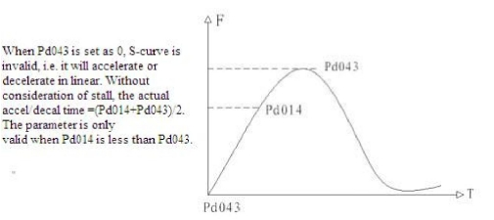

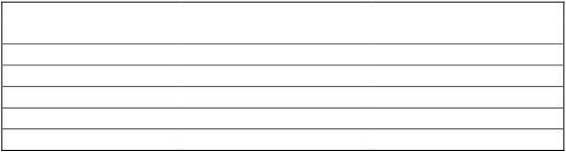

17: Ramp Time 1

18: Ramp Time 2
19: Multi-speed 1
20: Multi-speed 2
21: Multi-speed 3
22: High speed

23: Middle speed

This terminal can be used to select the ramp time of the
inverter.
4 kinds of ramp time are available for choice.
8-speed setting can be composed through Multi-speed 1, 2, 3.

High, middle and low speed can compose three kinds of
operation mode.
With different frequencies. In the three terminals the high-end

signal has priority. Low, Middle and High Speed are
determined respectively by Frequency 2, 3, 4.
24: Low speed

25: PID Valid
When this contact is closed, PID function starts. PID Function
start is only valid during operation.

26:
Internal control This contact can realize the internal control multi-speed clear

multi-speed clear reset reset.
27: UP Function When the switch of this terminal acts, the frequency setting of
the inverter will be increased or decreased by one unit.
When the switch of the terminal is held, the frequency will
increase or decrease rapidly to a point and then increase or
decrease at even speed. When the power is up again after the
power breakdown the changed frequency will not be
memorized.
28: Down Function
29: Drawing Start When this contact is triggered the drawing action starts.
31: Counter Pulse When this terminal is set for the counter it can receive the
pulse signal of ≤250HZ and counts.
32: Counter Reset When this contact acts it will clear the present counting values
displayed, restore C00 and restart counting.
Explanation:
1. Three multi-function terminals can be used for the connection method of
three-wire system for the realization of switching of FOR/REV rotation, which is
extensively applied in the cases of FOR/REV switching of photoelectric switches.
① Select D1, D2 and D3.
② Parameter setting:
Pd001=1 for external control; Pd044=02 for FOR rotation;
Pd045=03 for REV Rotation; Pd046=04 for Stop.
③ Action Description:
When triggering D1, the inverter will rotate forward (start);
When triggering D2, the inverter will rotate reverse;
When pressing STOP , the inverter will stop.

2. RUN, DCM, F/R can be used for Start, Stop and switching of FOR/REV:
① Select FOR, REV and RST.
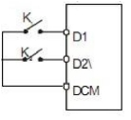

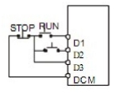

② Parameter setting: Pd001=1 for external control;
Pd044=01 for RUN function;
Pd045=05 for F/R switch;
When triggering FOR, the inverter will rotate forward (start); When triggering REV,
the inverter will rotate reverse.
3. Description of Ramp Time 1 and 2:

●

●
●
This function is only valid when Pd080 is set to 0, 2 and 3. Under the disturbance
and internal control multi-speed, it is invalid.
Any two multi-inputs can be combined for 4 kinds of ramp time for selection.
The related multi-inputs are set for Ramp Time 1, 2. Take the terminals of D4 and

D5 as example, when Pd047 of D4 is set to 22and Pd048 of D5 is set to 23, D4
and D5 are now Ramp Time 1, 2.

4. Function description of High, Middle and low speed terminals:

Note: ( 1 ) This function is only valid when Pd080 is set to 1, i.e. for 4-Speed of
external control.
( 2 ) Ramp time is determined by Ramp Select terminal.
( 3 ) When all high, middle and low speeds have signal inputs, it will give
priority in the sequence of high, middle and low speed.
5. Description of UP and DOWN Function:

Note: ( 1 ) The function of UP and DOWN is only valid when the operator is selected
for the source of the operating frequency, i.e. Pd002=0.
( 2 ) When the UP terminal is closed, the frequency of the inverter will increase.
( 3 ) When the DOWN terminal is closed, the frequency of the inverter will
decrease.
( 4 ) When both UP and DOWN terminals are closed at the same time, the
frequency will neither increase nor decrease. It is regarded as invalid.
RUN | D6 | D5 | D4 | Result
ON | OFF | OFF | OFF | Main speed, the frequency runs at the  set value of Pd003.
ON | ON | OFF | OFF | Low speed, the frequency runs at the  set value of Pd086.
ON | ON/OFF | ON | OFF | Middle speed, the frequency runs at  the set value of Pd087.
ON | ON/OFF | ON/OFF | ON | High speed, the frequency runs at the  set value of Pd088.

D4 | D5 | Result
OFF | OFF | Ramp Time 1
ON | OFF | Ramp Time 2
OFF | ON | Ramp Time 3
ON | ON | Ramp Time 4

UP | DOWN | Result
ON | OFF | Frequency increase
OFF | ON | Frequency decrease
ON | ON | Not increase or decrease

( 5 ) When the frequency reaches the max operating frequency, it will stop
increasing.
( 6 ) When the frequency reaches the min frequency or its lower limit, it will
stop decreasing.
( 7 ) After a power breakdown, the set value of CD000 will be memorized
instead of the frequency.

( 8 ) When using the function of UP and DOWN, the keys of

of the panel

are valid. After changing the values, it needs to press SET (ENTER) key
for confirmation and then the inverter can implement the action.
Meanwhile, the value will write to Pd003, which will be memorized after a
power breakdown.
( 9 ) When keeping pressing UP or DOWN, the frequency will increase or
decrease rapidly to a point and then increase or decrease at even speed.
( 10 ) The value changed by UP or DOWN can be set through Pd077 for
confirmation of whether it should be memorized or not memorized. For
details, refer to Pd077.
6. Function Description of Counter:

Note: (1) The signal width triggered should not be lower than 2 msec (t1, t2>2msec) .
(2) When the counting value is reached, the corresponding multi-output contact
will act.
(3) This counter can only count again after reset.
(4) When reaching to 65535, the counter will not count again.

Pd050
Pd051
Pd052
Pd053

Y1 Output
Y2 Output
FA, FB and FC Terminal Output
KA and KB Terminal Output
Set Range: 00-32

Factory Setting: 01
Factory Setting: 05
Factory Setting: 03
Factory Setting: 00
Unit: 1

01: RUN

The contact will act when the inverter has output or
receives the running command.

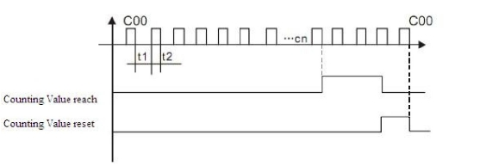

02: Zero Speed

03: Fault Indication

The contact will act when the output frequency of the
inverter is less than its starting frequency.
The contact will act when the inverter detects

abnormal conditions.
04: DC Braking Indication The contact will act when the inverter is in DC
braking.
05: Set Frequency Reach The contact will act when the output frequency of the
inverter reaches the set frequency.
06: In Accel The contact will act when the inverter is in ramp-up.
07: In Decel The contact will act when the inverter is in
ramp-down.
08:Uniform Frequency 1 Reach The contact will act when the output frequency of the
inverter reaches the designated frequency (Pd060).
09: Uniform Frequency 2 reach The contact will act when the output frequency of the
inverter reaches the designated frequency (Pd061).

10: Motor Overload Alarm

11: In Over-torque Detect
The contact will act when the inverter detects
over-load of the motor.
The contact will act when the inverter detects

over-torque.
12: Inverter Over-load Alarm The contact will act when the inverter detects
over-load.
13: Set Counter Reach The contact will act when the inverter implements
the external counter and the counting value is equal
to the set value (Pd065).
14: Middle Counter Reach The contact will act when the inverter implements
the external counter and the counting value is greater
than or equal to the set value (Pd066).
15: External Control Timer 1 reach The contact will act when the timer 1 reaches the set
value.
16: External Control Timer 2 reach The contact will act when the timer 2 reaches the set
value.
17: Low Voltage Alarm The contact will act when the inverter detects low
voltage.
18: Single Step End The contact will act and generate one pulse when the
inverter finishes a single step in implementation of
program operation.
19: Process End The contact will act and generate one pulse, when
the inverter finishes all the steps (i.e. after one cycle)
in implementation of program operation.
20:4~20mA Disconnected When AI input signal is opened the contact will act.
25: Auxiliary Pump 1 This contact controls the starting and stopping of
auxiliary pumps. For details, refer to Operation of
Multi-pumps.
26: Auxiliary Pump 2

27: Drawing Reach

28: PID Lower Limit Alarm

29: PID Upper Limit Alarm

30: Braking Resistor Act

31: Electromagnetic Relay Act

32: Fan Act

The contact will act when the drawing action is
finished. The contact will automatically reset when
the inverter stops.
This contact will act when the PID feedback is
smaller than the lower limit (the set value of Pd162).
This contact will act when the PID feedback is
greater than the upper limit (the set value of Pd161).
When the inverter is in running and the DC voltage
reaches the braking voltage the contact will act.
When the contact pulls in, the corresponding
multi-function terminal will act.
When the temperature of the inverter is increased or

it is in running, this contact will act.

Pd054 VO Output
Set Range: 0-7 Unit: 1 Factory Setting: 0
Functions: Output terminal of digital frequency, generating pulse or 0—10V analog.
In combination with Pd055, it can be connected with a corresponding
instrument with the measuring range below 10 to be used for external
monitoring.
0: 0~10V analog output, corresponding to output frequency. 0~10V corresponds to
0~Maximum operating frequency.
1: 0~10V analog output, corresponding to output current. 0~10V corresponds to
0~two times of the rated current of the inverter.
2: Analog output, corresponding to DC bus voltage. 0~10V corresponds to 0~1000V
3: Analog output, corresponding to AC output voltage. 0~10V corresponds to
0~510V/255V
(Note: The machine type of three phases, 380V corresponds to 510V and the machine
type of single phase, 220V corresponds to 255V).

Pd055 VO Analog Output Gain
Set Range: 0.0-100.0% Unit: 0.1% Factory Setting: 100.0
This parameter can be used to adjust the output voltage value of Multi-output 6 to
adapt to frequency meters with different measuring range and also used to correct a
frequency meter. For example, for an externally connected frequency meter with the
measuring range of 0~5V, a multi-function terminal can be used to display its
operating frequency. Then it can be corrected with this parameter. It can be achieved
by setting Pd055=50.

Pd056 Skip Frequency 1
Pd057 Skip Frequency 2
Pd058 Skip Frequency 3
Set Range: 0.00—400.00 Hz
Pd 059 Skip Frequency Range

**

Unit: 0.01Hz Factory Setting: 0.00
**

Set Range: 010—10.00 Hz

Unit: 0.01Hz

Factory Setting: 0.50

These three frequency skipping points are set for avoiding a mechanical resonance
point. In case of Pd059=0, all skip frequencies are invalid. The actual skip frequency
range is two times that of Pd059, as shown in the above diagram.

Pd060
Pd061

Uniform Frequency 1
Uniform Frequency 2

**

Set Range: 0.00—400.00 Hz Unit: 0.01 Hz Factory Setting: 0.00
Pd062 Uniform Frequency Range **
Set Range: 0.10—10.00 Hz Unit: 0.01 Hz Factory Setting: 0.50
When the output frequency is more than the uniform frequency, the corresponding
multi-outputs will act. The uniform frequency range acts as a hysteresis loop. When
the inverter is in the operation of multi-pumps, Pd060 (Uniform Frequency 1) is used
as high speed frequency and CD062 is set as low speed operating frequency. The
definitions of the corresponding multi-function contacts are changed.

Pd063

Timer 1 Time

Pd064
Set Range : 01 ~ 10.0

Timer 2 Time
Unit: 1
Factory Setting: 01

Set Range : 1 ~ 100 Unit: 1 Factory Setting: 1
Timer 1 is a timer of 01s ~ 10.0s and Timer 2 is a timer of 1s ~ 100s. When the timer
start at multi-inputs is closed (on) the timer starts to count time. When it reaches the
set time the corresponding multi-output contact will act. When the timer start is
opened (off) the timer time at the multi-output will be reset.
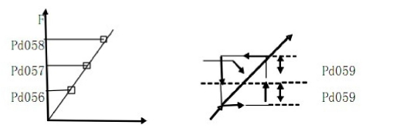

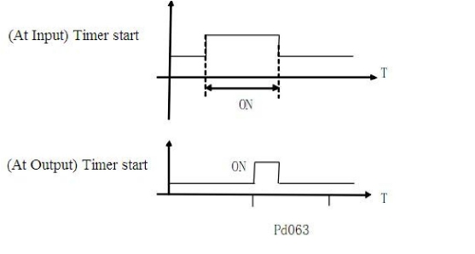

For example, set Pd063=5.0s. When the external control terminal (Multi-Input) is
valid, the output terminal will be valid after five (5.0) seconds, the signal of which can
be used to control other corresponding signals.

Pd065

Counting Value **

Set Range: 0-65500 Unit: 1 Factory Setting: 0
An external terminal of multi-function can be used as a trigger for the counter. When
the counter reaches the set value of Pd065, the corresponding multi-output contact
will act. After the counter is cleared and reset, it will start counting again. A proximity
switch or optoelectronic switch can be used for the triggering signals.

Pd066

Pulse Intermediate Counting Value

Set Range: 0-65500 Unit: 1
Refer to Pd065.
Factory Setting: 0

Pd067-Pd069

Reserved

Pd070

Analog Input Select

Set Range: 0-4 Unit: 1 Factory Setting: 0
0: 0~10V 1: 0~5V 2: 0~20mA 3: 4~20mA 4: 0-10V and 4-20mA stacked
This parameter can be set for different analog input signals.
When Pd070=4, the output frequency =1/2 (U/Umax + I/Imax ) x 50Hz
Among which: U: Analog Voltage; Umax: Maximum Analog Voltage;
I: Analog Current; Imax: Maximum Analog Current.

Pd071

Analog Filtering Constant

Set Range: 0-50 Unit: 1 Factory Setting: 20
The setting of this parameter is related to the analog responding speed. The higher the
value of Pd071 is set, the lower the analog responding speed will be.

Pd072

Higher Analog Frequency

Set Range: 0.00-400.00Hz
Unit: 0.01Hz Factory Setting: 50.00

Pd073
Lower Analog Frequency

Set Range: 0.00-400.00Hz
Unit: 0.01Hz Factory Setting: 0.00

Pd074

Bias Direction at Higher Frequency

Set Range: 0-1 Unit: 1 Factory Setting: 0
Pd075 Bias Direction at Lower Frequency
Set Range: 0-1 Unit: 1 Factory Setting: 0
0: Positive direction
1: Negative direction
Bias direction means the instruction of FOR/REV rotation command. Positive bias
indicates forward rotation while negative bias indicates reverse rotation.
For details, refer to the diagram in Pd076.

Pd076

Analog Negative Bias Reverse

Set Range: 0-1 Unit: 1 Factory Setting: 0
0: Negative bias Rev is not allowable.
1: Negative bias Rev is allowable.
The parameter group is set for the measuring range and zero point of the external
analog terminals and can be combined for any kind of curve to control the operation
of the motor.

Setting: Pd073=50 Pd075=1
Pd072=50 Pd074=0
Pd076=1
Note: this curve can be easily used in complicated
applications in combination with other curves. When
using it the instruction of FOR/REV run from external
terminals is still valid. When switching, the curve will turn
reverse.

Setting: Pd073=50 Pd075=0
Pd072=0 Pd074=0
Pd076=0

Note: this curve is a kind of special application of
reverse ramp setting. When using transmitter for the
control of pressure, temperature and others and while
the control has higher pressure and output signals, but
requiring the corresponding commands of stop or
deceleration on the inverter, this curve can satisfy the
demand properly.

Setting: Pd073=10 Pd075=1
Pd072=40 Pd074=0
Pd076=1

Note: this method is used extensively. The user can use
it flexibly.
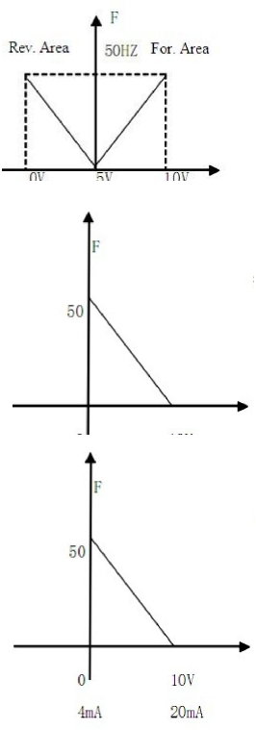

Setting: Pd073=10 Pd075=1
Pd072=40 Pd074=0
Pd076=0
Note: this curve is the extension of the above curve.
2V~10V (4.8mA~20mA) corresponds to 0Hz~40HZ; the
signal of 0V~2V (4~4.8mA) is invalid. It can be used to
avoid noise disturbance. In harsh environment it is better
not to use signals below 1V for setting the operating
frequency of the inverter.

Pd077

UP/DOWN Function

Set Range: 0-1 Unit: 1 Factory Setting: 0
0: Not memorized 1: Memorized
This parameter can be set for the selection of whether the values changed by the UP
or DOWN shall be memorized or not after stop. The changed values whether to be
memorized or not means when they are changed by UP or DOWN during operation
and the inverter is restarted after stop, these changed values shall be memorized or not
after restart. When Pd077 is set to 0, the changed value will not be memorized and
when it is set to 1, the changed values will be memorized. The set values of Pd003
will be memorized after restart.
For the related parameters, refer to Pd044-Pd049.

Pd078

UP/DOWN Speed

Set Range: 0-1 Unit: 1 Factory Setting: 0
0: 0.01Hz. Minimum UP/DOWN speed is 0.01Hz.
1: 0.1Hz. Minimum UP/DOWN speed is 0.1Hz.
Through the changes of this set value, the UP/DOWN speed unit can be adjusted to
meet the needs of different customers.

Pd079

Pd080

Reserved

Operation Mode

Set Range: 0-5 Unit: 1 Factory Setting: 0
0: Normal operation, i.e. the inverter is running in the normal control mode.
1: Internal control multi-speed (16-speed)
Note: ① 8-Speeds is made by adding the main frequency to the 7-speeds.
② The ramp up/down time is determined by Pd084 and Pd085.
③ The running time is set by Pd101~Pd116 timer. The unused control part can
be set as 0 by the timer.
④ The running direction of various frequencies can be set by Pd082 and
Pd083.
⑤ When the internal control multi-speed is running, the running time and
direction are set by the internal parameters. The external time switch and
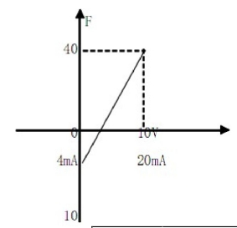

FOR/ REV. switch are invalid.
2. External control 4-speed (Refer to the function description and diagram of three
terminals of high, middle and low speed in Pd044~Pd049)
3. External control multi-speeds

Note: ① It is only valid to realize the external control 8-Speeds operation when
Multi-inputs are set for Multi-speed 1, 2, 3 and Pd080 is set to 3.
② Multi-speed 1, 2, 3 can be used to make up 7-Speeds and adding the main
frequency.
③ The frequencies of Speed Step 1 ~ Step 7 are determined by Pd086~Pd092.
④ Each ramp time is determined by D1-D6 external terminal.
⑤ The directions of each program operation are determined by the external
multi-function terminals.
⑥ The main frequency can be set in two ways. One method is to set it through
Pd003 and another is to set it through the potentiometer. When Pd002 is set
to 1, the frequency of Main Frequency is set by the potentiometer.
For the related parameters, refer to Pd003, Pd002 and Pd086~Pd092.
4. Disturbance (Traverse function)
This is a special parameter in the chemical fiber and printing and dying industries to
realize the traverse function. Except the commands of stop, external faults and
emergency stop all other commands are not accepted at running.
Note: ① The frequency at each inflection point is determined by Pd003 and Pd086.
② Skip Frequency is determined by Pd092.
③ Running Time is determined by Timer Pd101 and Pd102.
④ The related parameters: Pd003, Pd086~Pd116.
5. Drawing
Multi-function Terminals |  |  | Results
Multi-speed 1 | Multi-speed 2 | Multi-speed 3
OFF | OFF | OFF | Main frequency and frequencies are  determined by Pd003 or potentiometer.
ON | OFF | OFF | Multi-speed 1 and frequency are  determined by Pd086.
OFF | ON | OFF | Multi-speed 2 and frequency are  determined by Pd087.
ON | ON | OFF | Multi-speed 3 and frequency are  determined by Pd088.
OFF | OFF | ON | Multi-speed 4 and frequency are  determined by Pd089.
ON | OFF | ON | Multi-speed 5 and frequency are  determined by Pd090.
OFF | ON | ON | Multi-speed 6 and frequency are  determined by Pd091.
ON | ON | ON | Multi-speed 7 and frequency are  determined by Pd092.

This is a special parameter for the constant speed of unwinding and rewinding. By
using this function, the linear speed constant in certain accuracy can be realized.

Note: ① Through triggering of the external multi-function terminal, the drawing
action begins.
② In implementation of the drawing action, the actual running time is
T=Pd101 x 10.
③ When the drawing action is finished, the inverter will run at the constant
seed of Pd087 and the corresponding multi-output contact will act at the
same time. Until receiving the STOP command, the inverter will stop
running and the multi-output contact will reset.

Pd081

Auto PLA

Set Range: 0-3 Unit: 1 Factory Setting: 0
0: Stop after the program runs one cycle.
1: Cycling running.
2: Stop after it runs one cycle automatically (STOP for intervention).
3: Auto running and cycling (STOP for intervention)
This parameter setting is only valid when Pd080 is set to 4. For relevant Parameters,
refer to Pd003, Pd080, Pd082~Pd116.
Explanation:
1. Stop after the program runs one cycle.
When the command of auto program operation is given, the inverter will run with
each set value of internal parameters. It will run for one cycle and then stop
automatically. The inverter will not restart and run until it receives another command
of operation.
2. Cycling run.
When the command of operation is given, the inverter will run in sequence with the
frequency of every speed step and running time set by each of the internal parameters
and will recycle. During the cycling run, except the commands of stop, external faults
and emergency stop, all other commands will not be accepted.
3. Stop after it runs one cycle automatically (STOP for intervention).
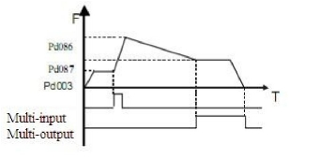

Note: 1) When the command of auto program operation is given, the inverter will run
with each parameter. But it will stop first and then restart at changing of
each step and will stop automatically after running for one cycle. The
inverter will not restart and run until it receives another command of
operation.
2) The frequencies of each speed step are set by Pd003, Pd086~Pd092.
3) The running times of each speed step are set by Pd101~Pd108.
4) The running direction is set by Pd082.

Pd082
Pd083
Running Direction of First 8-speeds
Running Direction of Last 8-speeds

Set Range: 0-255 Unit: 1 Factory Setting: 0
This parameter is only valid when Pd080 is set to 1.
This parameter setting determines the running direction of each frequency of
Pd086-Pd092, and Pd003 in the program operation. The setting method is as follows:
The rotation direction is set first in the binary 8 bits mode, and then converted to a
decimal value for the setting of this parameter. For instance:
The parameter 01001010 is converted into a decimal value, that is:

Then parameter Pd082=74
Pd083 is the setting for the last 8-speed running direction (the calculation method is
same as Pd082).

Pd084
Pd085

Ram Up Time of First 8-speeds
Ram Down Time of Last 8-speeds

Set Range: 0~65535 Unit: 1S Factory Setting: 0
This parameter is only valid when Pd080 is set to 1.
This parameter is set to determine the ramp time values of the internal control
multi-speed. The setting method is as follows:
(1) Determine each Ramp Time in the binary 2 bit mode:

(2) Determine the Ramp time of each speed step in the binary 16 bit mode:
Bit1 | Bit0 | Ramp Time
0 | 0 | Ramp Time 1 Pd014, Pd015
0 | 1 | Ramp Time 2 Pd016, Pd017
1 | 0 | Ramp Time 3 Pd018, Pd019
1 | 1 | Ramp Time 4 Pd020, Pd021

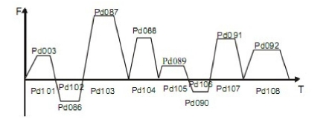

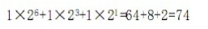

t1 Select Ramp Time 4
t2 Select Ramp Time 1

t3 Select Ramp Time 3
t4 Select Ramp Time 2
t5 Select Ramp Time 1
t6 Select Ramp Time 1
t7 Select Ramp Time 1
The setting value:
1x20+1x21+1x25+1x26=99
So Pd084 is set to 99.
Attach: 20=1 21=2 22=4 23=8
24=16 25=32 26=64 27=128

t8 Select Ramp Time 1

Pd085 is the last 8-step ramp time selection (the calculation method is same as
Pd084).

Pd086
Pd087
Pd088
Frequency 2
Frequency 3
Frequency 4
Factory Setting
Factory Setting
Factory Setting
15
20
25

Pd089 Frequency 5 Factory Setting 30
Pd090 Frequency 6 Factory Setting 35
Pd091 Frequency 7 Factory Setting 40
Pd092 Frequency 8 Factory Setting 0.50
Pd093 Frequency 9 Factory Setting 10
Pd094 Frequency 10 Factory Setting 15
Pd095 Frequency 11 Factory Setting 20
Pd096 Frequency 12 Factory Setting 25
Pd097 Frequency 13 Factory Setting 30
Pd098 Frequency 14 Factory Setting 35
Pd099 Frequency 15 Factory Setting 40
Pd100 Frequency 16 Factory Setting 45
Set Range: 0.00—400.00 Hz Unit: 0.01 Hz
This parameter is set in combination of the multi-inputs to select 4-speeds of external
control, multi-speeds of external control or multi-speeds of internal control.
For the relevant parameters, refer to the description of Pd080, Pd086-Pd100.

Pd101
Pd102
Timer 1
Timer 2
Factory Setting
Factory Setting
10.0
10.0

Pd103 Timer 3 Factory Setting 0.0
Pd104 Timer 4 Factory Setting 0.0
Pd105 Timer 5 Factory Setting 0.0
Pd106 Timer 6 Factory Setting 0.0
Pd107 Timer 7 Factory Setting 0.0
Pd108 Timer 8 Factory Setting 0.0
Pd109 Timer 9 Factory Setting 0.0
Pd110 Timer 10 Factory Setting 0.0
Pd111 Timer 11 Factory Setting 0.0
Step 8 |  | Step 7 |  | Step 6 |  | Step 5 |  | Step 4 |  | Step 3 |  | Step 2 |  | Step 1
t8 |  | t7 |  | t6 |  | t5 |  | t4 |  | t3 |  | t2 |  | t1
0 | 0 | 0 | 0 | 0 | 0 | 0 | 0 | 0 | 1 | 1 | 0 | 0 | 0 | 1 | 1

Pd112 Timer 12 Factory Setting 0.0
Pd113 Timer 13 Factory Setting 0.0
Pd114 Timer 14 Factory Setting 0.0
Pd115 Timer 15 Factory Setting 0.0
Pd116 Timer 16 Factory Setting 0.0
Set Range: 0.0—6500.0S Unit: 0.1S
This parameter is set for the internal control multi-speeds and the running time of
drawing function.
For the relevant parameter, refer to Pd080, Pd101~Pd116.

Pd117

Auto PLC Memory Function

0-1

Factory Setting: 0

0: Not memorized
1: Memorized
This parameter is set to determine whether the inverter is to realize the suspending
function in Auto PLC mode. In case of Pd115=1, it can memorize the status in which
the inverter is running and will memorize it at stop or fail. It will continue to run when
returning to normal. In case of Pd115=0, it will not memorize.

Pd118

Over-voltage Stall Prevention

Set Range: 0-1 Unit: 1 Factory Setting: 1
0: Over-voltage stall prevention invalid
1: Over-voltage stall prevention valid.
When the inverter is in deceleration, due to the effect of load inertia, the motor will
produce a return energy to the inverter and cause the DC voltage of the inverter to
increase. So when the function of over-voltage stall prevention is started, if the DC
voltage of the inverter becomes too high, the inverter will stop decelerating till the
voltage at DC decreases below the set value, then the inverter will go on to decelerate
and the ramp-down time will be extended automatically.

Pd119

Stall Prevention Level at Ramp-up

Set Range: 0-200% Unit: 1% Factory Setting: 150
When the inverter is in ramp-up, due to overload or too short ramp-up time, the output
current of the inverter will go up quickly and exceed the set standard level. When this
happens, the inverter will stop accelerating. When the current returns under its set
value, the inverter will go on to accelerate.
100% current is the rated current of the motor. When this parameter is set to 0, the
stall prevention function is invalid.

Pd120

Stall Prevention Level at Constant Speed

Set Range: 0-200% Unit: 1% Factory Setting: 0
When the inverter is running at constant speed, due to load fluctuation and other
reasons, the current will increase. When the current exceeds its set standard value, the
inverter will lower the output frequency. When the output current returns to its normal
range, the inverter will accelerate again to its set frequency.

100% current is the rated current of the motor. When this parameter is set to 0, the
stall prevention function is invalid.

Pd121

Decel. Time for Stall Prevention at Constant Speed Factory Setting: 5.0

When the inverter is used for the loads of kinds of fan and pump, Pd119 can be set to
120. When the current of the inverter is greater than 120%, the output frequency will
decrease and the current will also decrease accordingly. After the current returns to
normal, the frequency will return to normal slowly, so as to achieve the stall
prevention function. The decreasing speed of the frequency is determined by Pd119.
For the related parameters, refer to Pd119.

Pd122

Stall Prevention Level at Deceleration

Set Range: 0-200% Unit: 1
Please refer to Pd120.
100% current is the rated current of the motor.
Factory Setting: 150

Pd123

Over-torque Detect Mode

Set Range: 0-3 Unit: 1 Factory Setting: 0
0: When reaching the frequency, it starts to detect over-torque and when over-torque
is detected, it continues to run.
1: When reaching the frequency, it starts to detect over-torque and when over-torque
is detected, it stops running.
2: It detects over-torque during running and when over-torque is detected, it continues
to run.
3: It detects over-torque during running and when over-torque is detected, it stops
running.

Pd124
Over-torque Detect Level

Set Range: 0-200% Unit: 1% Factory Setting: 0
When the output current exceeds the over-torque detection level and also exceeds half
of the set time of over-torque detection (factory setting: 1.0s), the over-torque
detection will indicate, and the corresponding multi-function alarm contact will act.
When it exceeds the set time, the inverter will turn to self-protection. When this
parameter is set to 0, the over-torque detection will be invalid.

Pd125

Over-torque Detect Time

Set Range: 0.1-20.0S Unit: 0.1S Factory Setting: 1.0
When the inverter detects that the output current has exceeded the motor current set
value, the inverter begins to calculate the over-torque time. When the over-torque time
has exceeded half of the set detect time, the corresponding multi-function output
contact will act, and produce the over-torque alarm, while the inverter will keep
running. When the over-torque time has exceeded the set detect time (set by Pd125),
the inverter will turn to self-protection, display the fault information and stop output.
For the related parameters, refer to Pd123.

Pd126
Counter Memory

Set Range: 0-1
0: Not memorize
1: Memorize
Counter memory , inverter memory function
Pd127-Pd129
Reserved

Pd130
Number of Auxiliary Pump

Unit: 0

Factory Setting: 0

Set Range: 0-2 Unit: 1 Factory Setting: 0
This parameter is set for the number of auxiliary pump. The start or stop of the
auxiliary pumps is controlled by using the multi-output contacts and Auxiliary Pump
1 or Auxiliary Pump 2 is controlled through the peripheral control circuit.

Pd131

Continuous Running Time of Auxiliary Pumps

Set Range: 0-900(min) Unit: 1 Factory Setting: 60
In case of two pumps with only one pump in duty, in order to ensure each pump to
work evenly, it will be switched to another pump when its running time reaches the
set value of Pd131.

Pd132

Interlocking Time of Auxiliary Pump

Set Range: 1-250S Unit: 1 Factory Setting: 5S
This parameter is set to determine the interlocking time of two auxiliary pumps when
switching with each other.

Pd133

High Speed Running Time

Set Range: 1-250S Unit: 1 Factory Setting: 60S
In the application of water supply with constant pressure, when the master pump is
running at the frequency of high speed (set by Pd060) due to larger water volume and
the high speed running time is reached, the corresponding multi-function contacts act
and the auxiliary pumps start.

Pd134

Low Speed Running Time

Set Range: 1-250S Unit: 1 Factory Setting: 60S
In the application of water supply with constant pressure, when the master pump is
running at the frequency of low speed (set by Pd061) due to smaller water volume and
the low speed running time (Pd134) is reached, the corresponding multi-function
contacts act and the auxiliary pumps stop.
Pd133 and Pd134 must be used in combination of Pd060, Pd061 and multi-outputs.
Their main function is to increase or decrease the number of auxiliary pump.
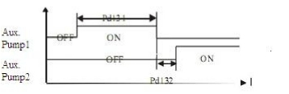

Pd135

Stopping Voltage Level

Set Range: 0-150% Unit: 1 Factory Setting: 95%
This parameter is set for the voltage level of the master pump entering into sleep
mode. For details, refer to the following description.

Pd136

Lasting Time of Stopping Voltage Level

Set Range: 1-250S Unit: 1 Factory Setting: 30S
This parameter is set for the lasting time under the stopping voltage level before
entering into sleep mode.

Pd137

Wakeup Voltage Level

Set Range: 0-150% Unit: 1 Factory Setting: 80%
This parameter is set for the wakeup voltage level from sleep to wakeup.

Pd138

Sleep Frequency

Set Range:0.00-400.00 Unit: 1 Factory Setting: 20.0
This parameter is set for the lowest operating frequency entering into sleep mode.

Pd139

Lasting Time of Sleep Frequency

Set Range: 1-250S
Unit: 1
Factory Setting: 20S
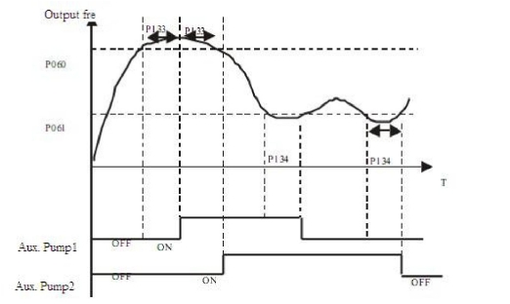

This parameter is set for the lasting time to run at sleep frequency when entering into
sleep mode.

Pd140
Reserved

Pd141

Rated Motor Voltage

Unit: 0.1V Factory Setting:*

It is set according to the rated voltage value of the nameplate of the motor. For the
inverters of 230V class, the factory setting is 220, while for the inverters of 400 V
class, the factory setting is 380.

Pd142

Rated Motor Current

Unit: 0.1A Factory Setting:*

It is set according to the rated value of the nameplate of the motor. This parameter can
be used to restrict the output current of the inverter to prevent over-current and protect
the motor. If the current of the motor has exceeded this value, the inverter of AC
motor will turn to self-protection.

Pd143

Motor Pole Number

Set Range: 02-10 Unit: 1 Factory Setting: 04
This parameter is set for the number of the motor's pole according to the nameplate of
the motor.

Pd144

Rated Motor Revolution

Set Range: 0-9999 Unit: 1r/min Factory Setting: 1440
This is set according to the actual revolution of the motor. The displayed value is the
same as this set value. It can be used as a monitoring parameter, which is convenient
to the user. This set value corresponds to the revolution at 50Hz.

Pd145

Auto Torque Compensation

Set Range: 0.1-10.0%
Unit: 0.1% Factory Setting: 2.0%
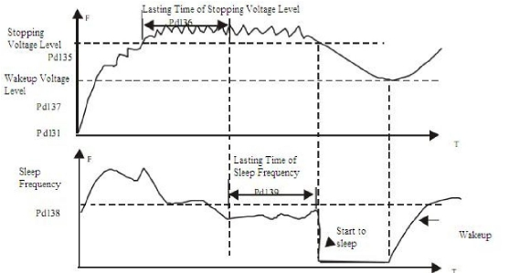

This parameter can be set for the auto output of extra voltage when the inverter is
running to a higher torque, which can compensate for the under-torque at lower
frequency. The torque compensation should not be too big and it should be set slowly
from low to high according to the actual situation. Insufficient compensation will
result in the under-torque of the motor at lower
frequency. And over compensation will lead to too
bigger torque, which will produce a shock to the
machine and even result in a trip of the inverter under
serious situation.

Pd146

Motor No-load Current

Set Range: 0-99 Unit: 1 Factory Setting: 40
The setting of motor no-load current will affect the value of slip compensation. The
current is 100% of the rated current of the motor.

Pd147

Motor Slip Compensation

Set Range: 0.0-10.0 Unit: 0.1 Factory Setting: 0.0
When the inverter drives the motor, the slip becomes bigger due to the increase of
load. This parameter can be set for slip compensation to decrease the slip and make
the running speed of the motor closer to the synchronous revolution.

Pd148-Pd149

Reserved

Pd150

Auto Voltage Regulation (AVR)

Set Range: 0-1 Unit: 1 Factory Setting: 1
0: Invalid 1: Valid
When the input power is not stable and if the voltage is too high, the operation of the
motor with the power exceeding the rated voltage will cause increase of the
temperature of the motor, damage of its insulation and unstable output torque. This
auto voltage regulation can automatically stabilize the output voltage within the rated
voltage range of the motor under the condition of unstable output power supply
When this function is set to invalid, the output voltage will fluctuate.

Pd151

Auto Energy Saving

Set Range: 0-10% Unit: 1% Factory Setting: 0
When it is set to zero, this function is invalid. When auto energy saving function is
started, the inverter will run at the full voltage during ramp-up or -down. During the
operation at constant speed, the inverter can automatically calculate the optimum
voltage value according to the power of load and supply power to the load to achieve
the goal of energy saving.
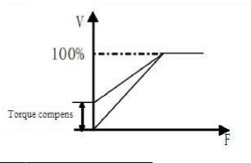

Pd152

Fault Restart Time

Factory Setting: 0

When the inverter is set for fault restart and if it has a fault trip with the time
exceeding the set value of Pd152, the inverter will restart. When using this function,
pay more attention to the safety.

Pd153

Restart after Instantaneous Stop

Set Range: 0-1 Unit: 1 Factory Setting: 0
0: Invalid, i.e. the inverter will not restart after an instantaneous power breakdown.
1: Start by frequency track. Refer to Pd025.

Pd154

Allowable Power-Breakdown Time

Set Range: 0.1-5.0S Unit: 0.1S
Factory Setting: 0.5

This parameter is set for the maximum allowable power failure time. If exceeding the
set time, the inverter will continue to stop output after power on.
To restart the inverter, it needs to follow the general starting procedures.

Pd155

Number of Abnormal Restart

Set Range: 00-10 Unit: 1
Factory Setting: 00

After the abnormal conditions (such as over-current and over-voltage) happens, the
inverter will automatically reset and restart. If the starting mode is set to normal mode,
it will start according to the normal procedures. If it is set to start by frequency track,
it will start in the frequency track mode. After starting, it will restore the set number
again if there is no more abnormality happened within 60 seconds. If there is still any
error and it reaches the set number, the inverter will stop output. It can only be started
after reset. When Pd155 is set to zero, the inverter will not carry out the functions of
automatic reset and restart.

Pd156

Proportional Constant (P)

**

Set Range: 0.0~100.00% Unit: 0.1% Factory Setting: 100%
This proportional constant is set for the error value gain. In case of I=0, D=0, it is
only for proportional control.

Pd157

Integral Time (I)

**

Set Range: 0.1~3600.0S Unit: 0.1S Factory Setting: 5.0S
The integral time (I) is set for the responding speed for PID. The larger the I value is
set, the slower the responding speed will be. To the contrary, if the responding speed
is quick but the integral time value is set too small, it will cause oscillation.

Pd158

Differential Time (D)

**

Set Range: 0.1~10.00S Unit: 0.01S Factory Setting: 0
This differential time (D) is set for the depression operation of PID. The larger the D
value is, the more obvious the depression operation will be. When D is set to zero,
this function is invalid.

Pd159

Target Value

**

Set Range: 0~100.0% Unit: 1% Factory Setting: *
This target value can be set through external voltage signal or the digital operator.
100% target value is corresponding to the analog frequency at +10V.
PID closed-loop control is usually used in the process control with physical quantity
not changing fast, such as the controls of pressure and temperature, etc. The feedback
signal is usually taken from temperature transmitter, or pressure transmitter, etc.
Under PID control, the feedback signal input path is the analog current signal of
4-20mA.
PID closed-loop control is valid when Multi-input PID is started.
PID Control Block Diagram:

General operating methods of PID control:
(1) Choose the correct transmitter (with the output specification of standard current
signal 4-20mA)
(2) Set the right target value.
(3) If the output does not have oscillation, increase the proportional constant (P).
(4) If the output does not have oscillation, decrease the integral time (Ti)
(5) If the output does not have oscillation, increase the differential time (Td).
(6) Concrete applications can be referred to the example application descriptions in
Appendix 1.

1. Suppress the Over Output
a: Decrease the differential
time (D value)
b: Increase the integral time (I
value)
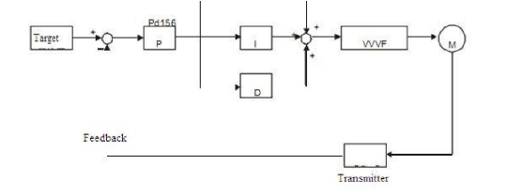

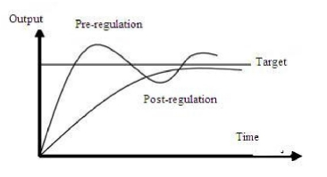

2. Suppress the oscillation

a: Decrease the differential time
(D value) or set it to zero.
b: Decrease Proportional
Constant (P value)

Pd160

PID Target Value

**

Set Range: 0-1 Unit: Factory Setting: 0
The target value can be set through the selection of the panel or external analog. The
external analog is 0~10V signal or given by the potentiometer.
When Pd160=0, the target value of PID is the value set by Pd159.
When Pd160=1, the target value of PID is the value of the external analog 0-10V
(corresponding to 0-100%), the setting of Pd159 is invalid.

Pd161

PID Upper Limit

**

Set Range: 0~100% Unit: Factory Setting: 100%
When PID feedback value is more than the set value of Pd161, the corresponding
multi-output will act and the inverter will not stop.

Pd162

PID Lower Limit

**

Set Range: 0~100% Unit: Factory Setting: 0%
When PID feedback value is less than the set value of Pd162, the corresponding
multi-output will act and the inverter will not stop.

Pd163

Communication Addresses

Set Range: 00-250 Unit: Factory Setting: 00
When the inverter is set for RS-485 Communication interface control, each of the
inverters will be set for its individual identification number.
00: No communication function.
01~250: Address for the inverters

Pd164

Communication Band Rate

Set Range: 0-3
0: 4800 b/s 1: %00 b/s 2: 19200 b/s
Unit: Factory Setting: 1
3: 38400 b/s

Pd165

Communication Data Method

Set Range: 0-5
0: 8N1 For ASCII 1: 8E1 For ASCII
3: 8N1 For RTU 4: 8E1 For RTU
Unit: 1 Factory Setting: 0
2 :8O1 For ASCII
5: 8O1 For RTU

Pd166-Pd168

Reserved

MODBUS Communication Protocol
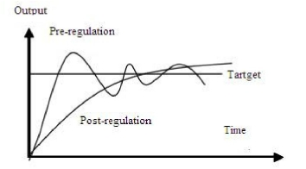

1. ASCII mode:
Mode of communication data

(1) STX Starting unit " : " (3AH)
(2) ADDR communication address, 8-bit data is composed of two ASC II bytes.
01~250: Address of the corresponding inverters.
(3) CMDFUNC: Function code 8-bit command

●
●
●
●
●
●
●
01 Read the single code data
03 Read register
04 Read input register
05 Write the single code data status
06 Write the single register
0F Write multi- code data status
10 Write multi-register

a: Read function code data
Send the data format:
“:” ADDRESS 01 ADDRH ADDRL NUMH NUML LRC 0X0D 0X0A
Note: ADDR: 0X00000--- 0X FFFF; NUM: 0X0001---0X 0020 (NUM means the
number of code data to be read)
The format of normal returned data:
“:” ADDRESS 01 BYTECOUNT DATA1 DATA2 DATA3 DATAN LRC 0X0D 0X0A
Note: BYTECOUNT = NUM/8 or BYTECOUNT = NUM/8 + 1 (taken as a whole or
whole +1)
Format of wrong returned data:
“:” ADDRESS 0X81 01 or 02 or 03 or 04 LRC 0X0D 0X0A
eg. Read the status of current running of the inverter
ASII format
Send: 3A 30 31 30 30 30 35 30 30 30 31 3F 39 0D 0A
Return: 3A 30 31 30 31 30 31 30 31 46 43 0D 0A (ASII)
The returned data bite “01” (hexadecimal) is converted into 2-byte “0000 0001”, the
last one means the running status; “1” means the inverter is under REV. running (“0”
for FOR. Rotation or STOP, refer to specific description)

b. 03 read data register
Send the data format:
“:” ADDRESS 03 ADDRH ADDRL NUMH NUML LRC 0X0D 0X0A
Note: ADDR: 0--- 0XFFFF; NUM: 0X0001---0X 0020 (NUM means the number of
data register to be read)
The format of normal returned data:
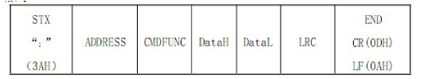

“:” ADDRESS 03 BYTECOUNT DATA1 DATA2 DATA3 DATAN LRC 0D 0A
Note: BYTECOUNT = 2 * NUM
Format of wrong returned data:
“:” ADDRESS 0X83 01 or 02 or 03 or 04 LRC 0X0D 0X0A
eg. Read the value of function code in Pd003 (eg. 30.00Hz)
RTU Format send: “:” 03 00 00 00 00 01 FC 0D 0A (hexadecimal)
ASCII Format send: 3A 30 33 30 30 30 30 30 30 30 3A 46 43 0D 0A (ASCII)
RTU Format data returned: “:” 01 03 02 0B B8 37 0D 0A (hexadecimal)
ASCII Format data returned: 3A 30 31 30 33 30 32 30 42 42 38 33 37 0D DA
The bite of data returned “0BB8” (hexadecimal) means P003 = 30.00

c. 04 read input data register
Send the data format:
“:” ADDRESS 04 ADDRH ADDRL NUMH NUML LRC 0X0D 0X0A
Note: ADDR: 0--- 0XFFFF; NUM: 0X0001---0X 0004 (NUM means the number of
code data to be read)
The format of normal returned data:
“:” ADDRESS 04 BYTECOUNT DATAH1 DATAL1 – DATAHN DATALN
Note: BYTECOUNT = NUM * 2
Format of wrong returned data:
“:” ADDRESS 0X84 01 or 02 or 03 or 04 LRC 0X0D 0X0A
eg. The current temperature of the inverter
RTU Format send: “:” 01 04 00 06 00 01 F4 0D 0A
ASCII Format send: 3A 30 31 30 34 30 30 30 36 30 30 30 31 46 34 0D 0A
RTU data returned: 01 04 02 01 6A 8E 0D 0A
ASCII data returned: 3AC 30 31 30 34 30 32 30 31 36 41 38 45 0D 0A
The bite of data returned is 0x16A, means the temperature is 36.2

d. Write single data status
Send the data format:
“:” ADDRESS 05 ADDRH ADDRL NUMH NUML LRC 0X0D 0X0A
Note: ADDR: 0--- 0XFFFF DATA: 0X0000 or 0XFF00 (0XFF00 valid)
The format of correct returned data:
“:” ADDRESS 05 ADDRH ADDRL DATAH DATAL LRC 0X0D 0X0A
The format of wrong returned data:
“:” ADDRESS 0X85 01 or 02 or 03 or 04 LRC 0X0D 0X0A
eg. Inverter running through communication control
Data sent through RTU: 01 05 00 48 FF 00 B3 “0D 0A” (hexadecimal)
Data sent through ASCII: 3A 30 31 30 35 30 30 34 38 46 46 30 30 42 33 0D 0A
(ASCII)
Data returned through RTU: 01 05 00 48 FF 00 B3 “0D 0A” (hexadecimal)
Data returned through ASCII: 3A 30 31 30 35 30 30 34 38 46 46 30 30 42 33 0D 0A
(ASCII)

e. 06 Write single data register
Send the data format:
“:” ADDRESS 06 ADDRH ADDRL DATAH DATAL LRC 0X0D 0X0A
Note: ADDR: 0--- 0XFFFF
Correct returned data:
“:” ADDRESS 06 ADDRH ADDRL DATAH DATAL LRC 0X0D 0X0A
Wrong returned data:
“:” ADDRESS 0X86 01 or 02 or 03 or 04 LRC 0X0D 0X0A
eg. Write 1.84Hz into inverter P003
Data sent through RTU: 01 06 00 03 00 B8 36 0D 0A (hexadecimal)
Data sent through ASCII: 3A 30 31 30 36 30 30 30 33 30 30 42 38 33 45 0D 0A
(ASCII)
Data returned through RTU: 01 06 00 03 00 B8 79 B8 (hexadecimal)
Data returned through ASCII: 3A 30 31 30 36 30 30 30 33 30 30 42 38 33 45 0D 0A
(ASCII)
The bite of data returned is “00BB” (hexadecimal), means the setting for P003 is 1.84.

f. OF Write multi-data status
Send the data format:
“:” ADDRESS OF ADDRH ADDRL NUMH NUML COUNT DATAH1 DATAL1
DATA2H DATA2L – DATANH DATANL LRC 0X0D 0X0A
Note: ADDRR: 0X000 – 0X00FF; DATA: 0X0000 ~ 0X00FF
NUM: 0X0000 – 0X0007; COUNT: NUM/8 or NUM/8 + 1 (NUM means the number
of data to be written)
The format of correct returned data:
“:” ADDRESS OF ADDRH ADDRL NUMH NUML LRC 0X0D 0X0A
The format of wrong returned data:
“:” ADDRESS 0X8F 01 or 02 or 03 or 04 LRC 0X0D 0X0A
eg. Send REV. rotation and running command to the inverter at the same time
Data sent through RTU: 01 0F 00 48 00 03 01 00 05 9F 0D 0A (hexadecimal)
Data sent through ASCII: 3A 30 31 30 46 30 30 34 38 30 30 30 33 30 31 30 30 30 35
39 46 0D 0A
Data returned through RTU: 01 0F 00 48 00 03 A5 0D 0A (hexadecimal)
Data returned through ASCII: 3A 30 31 30 46 30 30 34 38 41 35 0D 0A (ASCII)

g. 10 Write multi-data register
Send the data format:
“:” ADDRESS 0x10 ADDRH ADDRL NUMH NUML BYTECOUNT DATAH1
DATAL1 DATA2H DATA2L – DATANH DATANL LRC 0X0D 0X0A
NUM: 0X0000 – 0X0000 – 0XFFFF; NUM: 0X000-0X00FF (NUM means the
number of data register)
BYCOUNT = NUM * 2
The format of correct returned data:
“:” ADDRESS 0x10 ADDRH ADDRL NUMH NUML LRC 0X0D 0X0A

The format of wrong returned data:
“:” ADDRESS 0X90 01 or 02 or 03 or 04 LRC 0X0D 0X0A
If 1.84 is input into Pd003 and 0.2 into Pd004 simultaneously
Data sent through RTU: 01 10 00 00 00 02 04 0B B8 00 02 D6 0D 0A (hexadecimal)
Data sent through ASCII: 3A 30 31 31 31 30 30 30 33 30 30 32 30 34 30 30 42 38 30
30 30 32 32 43 0D 0A (ASCII)
Data returned through RTU: 01 10 00 03 00 02 B1 C8 0D 0A (hexadecimal)
Data returned through ASCII: 3A 30 31 31 30 30 30 33 30 30 30 32 45 41 0D 0A
(ASCII)
The data sent to be input into 16-byte data “0x00b8” AND “0x02” means 1.84 and 0.2
are input respectively.
Wrong communication codes:
01 Illegal function code
02 Illegal data address
03 Illegal data
04 Device failures

Introduction of function codes
Introduction of function data codes
Data | Description | R/W | Note
0000 | Reserved | R
0001 | Reserved | R
0002 | Reserved | R
0003 | Running | R | 0-Stop 1-Run
0004 | Jogging | R | 0 -Invalid 1 –Jogging
0005 | FOR./REV. Rotation | R | 0-FOR 1-REV
0006 | Braking | R | 0 –Invalid 1 -Brake P02-00=0
0007 | Frequency track | R | 0–Invalid 1-Frequency track  P02-00=0
0008 | IGBT Short circuit | R | 0 -Invalid1 -Error ‘OC’
0009 | CT over-current detect high | R | 0 -Invalid1 -Error ‘OC’
000A | CT over-current detect low | R | 0 -Invalid1 -Error ‘OC’
000B | Earth short circuit | R | 0 -Invalid1 -Error ‘GF’
000C | Over-voltage | R | 0 -Invalid1 -Error ‘OU’
000D | Fuse break | R | 0 -Invalid1 -Error ‘FB’
000E | Low-voltage | R | 0 -Invalid1 -Error ‘LU’
000F | Inverter over-heating | R | 0 -Invalid1 -Error ‘OH’'
0010 | Inverter over-load | R | 0 -Invalid1 -Error ‘OL’
0011 | Motor over-load | R | 0 -Invalid1 -Error ‘OA’'
0012 | Motor over-torque | R | 0 -Invalid1 -Error ‘OT’
0013 | Connector fault | R | 0 -Invalid1 -Error ‘LU’
0014 | Braking pipe fault | R | 0 -Invalid1 -Error ‘BT’
0015 | CPU fault | R | 0 -Invalid1 -Error ‘FE’

Introduction of data register code functions
The function code addresses are same as the parameters shown on the keyboard.
Introduction of input register code function addresses

4) DATA: data content: n x 8-bit
0016 | Register fault | R | 0 -Invalid1 -Error ‘BE’
0017 | Master fault indication | R | 0 -Invalid1 -Error ‘KE’
0018 | Inverter over-load | R | 0 -Invalid 1 -Alarm OL’
0019 | Motor over-load | R | 0 -Invalid 1 -Alarm 'OA'
001A | Motor over-torque | R | 0 -Invalid 1 -Alarm 'OT'
001B | Temperature too high | R | 0 -Invalid 1 -Alarm 'OH'
001C | Emergency stop | R | 0 -Invalid 1 -Alarm 'ES'
001D | CRC inspection | R | 0 -Invalid 1 -Alarm 'ER’
001E | 4- 20MA break | R | 0 -Invalid 1 -Alarm ‘20’
001F | Para setting wrong | R | 0 -Invalid 1 -Alarm ‘PR’
0020 | Multi-input FB | R | 0—Invalid 1 一 Valid
0021 | Multi-input MCS | R | 0—Invalid 1 一 Valid
0022 | 01Terminal input | R | 0—Invalid 1 一 Valid
0023 | 02Terminal input | R | 0—Invalid 1 一 Valid
0024 | 03Terminal input | R | 0—Invalid 1 一 Valid
0025 | 04Terminal input | R | 0—Invalid 1 一 Valid
0026 | 05Terminal input | R | 0—Invalid 1 一 Valid
0027 | 06Terminal input | R | 0—Invalid 1 一 Valid
0048 | RUN | W | 0000—Invalid FF00—Valid
0049 | FOR | W | 0000—Invalid FF00—Valid
004A | REV | W | 0000—Invalid FF00—Valid
004B | STOP | W | 0000—Invalid FF00—Valid
004C | F/R | W | 0000—Invalid FF00—Valid
004D | JOG | W | 0000—Invalid FF00—Valid
004E | JOGF | W | 0000—Invalid FF00—Valid
004F | JOGR | W | 0000—Invalid FF00—Valid

Input register address | Description | R/W | Note
0000 | Output frequency | R
0001 | Set frequency | R
0002 | Output current | R
0003 | Output rotation | R
0004 | DC voltage | R
0005 | AC voltage | R
0006 | Counter | R
0007 | Temperature | R
0008 | PID target value | R
0009 | PID feedback value | R

5) LRC:
ASCII mode: Get LRC methods is that add ADDR to the last data, if the result is more
than 256,then the result subtract 256 until the result is less then 256 (if the result is
11128H, take 1128H) ,then 100H subtract the result to get LRC.

2. RTU mode

CRC calculating method of the check codes is the same as that of CRC.
Eg. Write 30.00Hz to inverter of 03

Sent data: 01H 06H 00H 03H 0BH B8H 8EH 88H

Pd170

Display Items

Set Range: 0-5 Unit: 1 Factory Setting: 0
This parameter is only valid when Bit 2 is set to 1 in CD168.
For the details, refer to Pd171.
0: Inverter Temperature
1: Counter Value
2 PID Target Value
3: PID Feedback Value

Pd171

Display Items Open

Set Range: 0-15 Unit: 1 Factory Setting: 0
This parameter is set for selection of displaying of DC voltage, AC voltage and other
items, so that the customer can monitor and view them in sequence through the switch
key.
It can be set first in the binary 3 bits mode, and then converted to a decimal value.

In the contents displayed the factory setting is to show output frequency, set frequency,
output current and output revolution through the switch key. If it is necessary to view
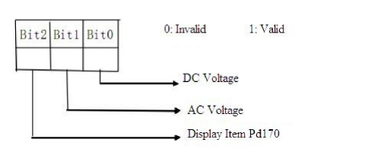

ADDR | FUNCL | DATAH(ADDRESS) | DATAL(ADDRESS) | DATAH | DATAL | CRCH | CRCL
01H | 06H | 00H | 03H | 0BH | B8H | 8EH | 88H

Quiet | ADDR | FUNCL | DATAH | DATAL | CRCH | CRCL | Quiet
>  50ms |  |  |  |  |  |  | >  50ms

and monitor other items, they can be set through Pd170 and Pd171.

Pd172

Fault Clear

Set Range: 00-10
01 is for fault clear. Others have no function.
Unit: 1 Factory Setting: **

Pd173

Inverter Voltage Class

Unit: 1V Factory Setting: *

It is factory setting, and is decided by the model. It can be observed, but not set.

Pd174

Inverter Current Class

Unit: 1A Factory Setting: *

It is decided by the model and can not be changed.

Pd175

Inverter Model

Set Range: 0-1 Unit: 1 Factory Setting: 0
0: Constant torque 1: For kinds of fan. It can be observed, but not changed.

Pd176

Inverter Frequency Standard

Unit: 1

Factory Setting: *

0: 50Hz
1: 60Hz It is factory setting. It can be observed, but not set.

Pd177
Pd178

Fault Record 1
Fault Record 2

Factory Setting: ————
Factory Setting: ————

Pd179 Fault Record 3 Factory Setting: ————
Pd180 Fault Record 4 Factory Setting: ————
When it has no fault record it shows ----. After access to this parameter, the fault
display can be checked.

Pd181

Software Version

Factory Setting: *

It can be observed, but not set.

Pd182

Manufacture Date

Factory Setting: *

It is factory setting. It can be observed, but not set.

Pd183

Serial No.

Factory Setting: *

It is factory setting. It can be observed, but not set.

Pd183~Pd250 Factory Setting
Note: * means the said parameter has a variety of set values or should be set
specifically according to concrete conditions
** means the said parameter can be set during the operation.

X. Care & Maintenance, Fault Information and Troubleshooting

Periodical maintenances and inspections will keep your inverter in its normal state for
long time.

1. Precautions about Inspection and Maintenance

●

●

●

●

●

2.
●

●

●
●
●

●

●
●

●

3.
Be sure to turn off the power supply to the inverter (R.S.T) first before the
inspection and maintenance.
After confirming the main circuit power supply has been turned off and the
display has disappeared, wait until the internal indicator lamp for high voltage
goes out before performing the inspection and maintenance.
During the inspection, do not pull out or wrongly distribute the internal power
supply, wires and cables. Otherwise it will cause malfunction or damage to the
inverter.
Do not leave any screw or other part inside the inverter during the installation, or
it will result in the short circuit of circuit board.
Keep the inverter clean, free from dust, oil mist and moisture after the
installation.

Periodical Inspection and Maintenance items
Check whether the power supply voltage conforms to the rated voltage of the
inverter.
(Pay special attention to that whether there is any damage on the power supply
wires and the motor.)
Check whether the wiring terminals and the connectors are tight.
(Check whether the power supply wires and terminal connection wires have any
broken strand).
Check whether there is dust, iron filings or corrosive fluid in the inverter.
Measuring the insulation impedance of the inverter is forbidden.
Examine the output voltage, output current and output frequency of the inverter.
(The measuring results should not have too big difference.)
Check whether the ambient temperature of the inverter is between -5°C and
40°C and whether the installation environment has good ventilation.
Check whether the humidity is kept below 90% (without condensation).
Check whether the motor makes unusual noises or abnormal vibration in running.
(The inverter should not be installed in a place with high vibration.)
Please make periodical cleaning of vent holes.

Fault Indication and Troubleshooting

The inverter of RLP series is relatively perfective with the protection functions of
overload, inter-phase short circuit, earth short circuit, under-voltage, overheating and
over-current, etc. When a protection function happens with the inverter, please check
the reasons of faults according to the information listed in the table below. The
inverter can be restarted after the disposal. If the fault cannot be disposed, please

contact the local distributor.
Fault  Display | Fault Contents &  Description | Disposal methods
E.OC.A | Over-current during  ramp-up | 1: Check whether the motor has got short circuit  or partial short circuit and whether the insulation  of output wire is good.  2: Extend the ramp-up time.  3: The configuration of the inverter is not  reasonable. The inverter's capacity should be  increased.  4: Decrease the torque and increase the set value.
E.OC.n | Over-current at  constant speed | 1: Check whether the motor has got short circuit  and whether the insulation of the output wires is  good.  2: Check whether the motor is blocked and  whether there is a sudden change of mechanical  load.  3: Check whether the inverter's capacity is too  small and increase its capacity.  4: Check whether there is a sudden change in the  power supply voltage.
E.OC.d  E.OC.S | Over-current at decel  Over-current at stop | 1: Check whether the insulation of the output  wires is good and whether the motor has got  short circuit.  2: Extend the Ramp-down Time.  3: Replace it with an inverter of larger capacity.  4: DC braking is too high. Decrease DC braking.  5: The inverter has failure. Please send it to the  factory for repair.
GF | Short circuit | 1: Check whether the connection wire of the  motor has got short circuit.  2: Check whether the insulation of the output  wires is good.  3: Please send it for repair.
E.OU.S  E.OU.a  E.OU.n  E.OU.d | Over-voltage at stop  Over-voltage at accel  Over-voltage at  constant speed  Over-voltage at decel | 1: Extend the Ramp-down Time or add a braking  resistor.  2: Improve the mains supply voltage and check  whether there is any sudden change in the  voltage.
Fb | Fuse break | The fuse breaks. Please send it for repair.

Code Comparison Table:

4. Faults and Analysis
(1) When RUN key is pressed, the motor does not run.
1) The setting of operation mode is wrong, i.e., under the operation mode of
external control terminals, the inverter is started by the digital operator or
under the operation mode of the digital operator; it is started by the external
control terminals.
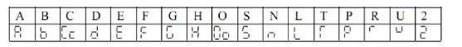

OH | Overheat of Inverter | 1: Check whether the fan is blocked and whether  there is any foreign matter stuck in the cooling  fins.  2: Check whether the ambient temperature is  normal.  3: Check whether there is enough space for  ventilation and good air convection.
OL | Inverter overload,  150% per 1min | 1: Check whether the capacity of the inverter is  lower. Otherwise it should be increased.  2: Check whether there is any jamming in the  mechanical load.  3: The setting of V/F curve is bad. Set it again.
OA | Motor overload,  150% per 1min | 1: Check whether there is any sudden change in  the mechanical load.  2: The equipped motor is too small.  3: The motor is hot and the insulation becomes  bad.  4: Check whether the voltage has big fluctuation.  5: Check whether there is any phase missing.  6: The mechanical load is increased.
OT Motor over-torque 1: Check whether there is any fluctuation in the
mechanical load.
2: Check whether the equipped motor is smaller.

Er | External interference | Isolate the interference source
ES | Emergency Stop | In Emergency Stop
20 | 4-20mA wire broken | Join the broken wire
Pr | Setting error | Correct the setting
DCb | DC brake status | In DC braking

2) The frequency reference is too low or not set.
3) The peripheral wiring is wrong. For example, the setting of wiring of two- wire
system and three-wire system and other related parameters have errors.
4) The setting of multi-function terminals is wrong (in the external control).
5) The inverter is in the fault protection.
6) The motor fails.
7) The inverter fails.

(2) The parameters cannot be set.
1) Password locks. Please decrypt it first before resetting.
2) The inverter is in running.
3) The connection of the connecting parts is abnormal. The communication of the
digital operator is abnormal. Take out the operator after power-off and then
mount it again for a trial.

(3) The motor cannot rotate reverse.
Reverse rotation is disabled.

(4) The motor rotates in the opposite direction.
The output line is wrongly connected. Please change any two lines of U.V.W over.

(5) The deceleration of the motor is too slow.
1) The setting of Ramp-down Time is too long. Decrease Ramp-down Time.
2) Add a braking resistor.
3) Add a DC brake.

(6) Over-heat of the motor
1) The load is too large. The actual torque has exceeded the rated torque of the
motor. It is recommended to increase the capacity of the motor.
2) The ambient temperature is too high. In a place with higher temperature the
motor will be burn out. Please decrease the temperature around the motor.
3) The phase to phase withstand voltage of the motor is insufficient. The switch
actions of the inverter will make the winding coil of the motor produce shock
wave. Typically the maximum shock voltage will reach 3 times that of input
power of the inverter. Please select a motor with higher phase to phase
withstand voltage against shock than the maximum shock voltage.

(7) The starting of the inverter interferes with other control devices
1) Decrease the carrier frequency and reduce the number of actions of internal
switches.
2) Install a noise filter at the power input of the inverter.
3) Install a noise filter at the output of the inverter.
4) Make correct grounding for the inverter and the motor.
5) Use metal conduit to tube the cable to shield it.

6) Make separate wiring for the main circuit wires and control wires.

(8) When the fan starts the inverter detected an over-current stall.
1) At start the fan rotates idly. Please set it for DC braking at start.
2) When DC braking at start has been set, increase the DC braking value.

(9) The machine has the noise of vibration or roar
1) The vibration frequency of mechanical system resonates with the carrier. Adjust
the carrier to avoid the point of resonance.
2) The vibration frequency of mechanical system resonates with the output
frequency of the inverter.
a. Set it for skip function to avoid the point of resonance.
b. Put rubber vibration isolator on the base plate of motor.

Common abnormities and solutions
The analysis and measures for the common abnormities refer to the following table:
Abnormity |  |  | Possible Causes and Solutions
Mot  or  Not  Run | No display on  keyboard | Examine whether the power supply is on, the input power  has phase or is connected correctly
Mot  or  Not  Run | The keyboard does  not display, but the  charge indicator  lamp is ON | Examine the wires of the keyboard and the socket;  Measure the voltage of controlled power supply, so as to  confirm whether the switch power is running normally;  If the switch power is not running properly, examine  whether the socket of switch power inlet (P, N) is  connected well, whether the vibration resistance is  damaged or the stabilizing pipe is normal.
Mot  or  Not  Run | No voltage of low  voltage of PN  terminal | Examine the charging return circuit.
Mot  or  Not  Run | Motor buzz | The motor is under heavy load, please try to reduce the  load.
Mot  or  Not  Run | No abnormity is  found | Check whether the inverter is in the state of trip or has not  been reset after trip; whether it is in the state of restart  after power break; whether the keyboard is reset; whether  it accesses to the program running state or the multi-speed  running state. For the running state or non-running state,  use the method of restoring the factory setting to confirm  whether the running command is given. Examine whether  the running frequency is set as 0.
Motor can not accelerate  or decelerate smoothly |  |  | Inappropriate setting of ramp time;  Too low current amplitude;  Over-voltage protection during deceleration;  Inappropriate setting of carrier frequency, over-load or  vibration appears

Too high or too low  motor rotation speed | Inappropriate V/F feature selection;  Incorrect V/F feature level selection, to be reset;  Substandard or non-standard rated voltage of motor;  Too low voltage of power supply;  Incorrect setting of frequency set signal gain;  Incorrect setting of output frequency.

XI. Selection of Peripheral Devices and Disposition

1. Options

Description
Functions

NFB or Ground fault interrupter for Protect the wiring of the inverter. Be sure to

wire connection
install a breaker at the power. Please select a

ground fault
circuit interrupter against

high-order harmonics.

Electromagnetic contactor

Surge absorber

Isolating transformer

In order to prevent the braking resistor from
burning out, please add an electromagnetic
contactor and connect a surge absorber to the
coil when using it.
Absorb the switching surge current from the
electromagnetic contactor and control relays.

Its function of isolating the input and output of

the
inverter is effective to reduce the

interference to other electric devices.

DC reactor
AC reactor

Braking resistor, braking unit
Improve the input power factor of the inverter.
Improve the input power factor of the inverter
and prevent the shock of surge voltage.
Consume the regenerating energy of the motor

and shorten the ramp-down time.
1) Leakage switch
There is earth static capacity inside of the inverter and the motor as well as the input
and output leads. Due to higher carrier frequency of the inverter, the inverter has
higher earth leakage current, especially for the inverters of large capacity series.
When using a leakage switch, it may sometimes result in the error action of the
protective circuit. So when using a leakage switch, attention should be paid to its
selection and the proper reduction of carrier frequency and shortening the leads, etc.
2) AC reactors
An AC reactor can constrict the high-order harmonic of input current of the inverter to
improve its input power factor and prevent the shock of surge. It is recommended to
use an input AC reactor under the following circumstances:
a: Three-phase power supply is in unbalance.
b: Any equipment with thyristor or power factor compensation unit with switching
control is connected to the same power supply.
3) DC reactors
It is necessary to install a DC reactor when the capacity of power supply is more than
1000 KVA or the mains power capacity is higher than the rated capacity of the
inverter. A DC reactor is also needed for the case with higher demand on the
improvement of power factor of power supply. This DC reactor can be used together
with an AC reactor to achieve the obvious effect of decreasing high-order harmonic at
input. If it is necessary to install a DC reactor, please contact the local distributor.
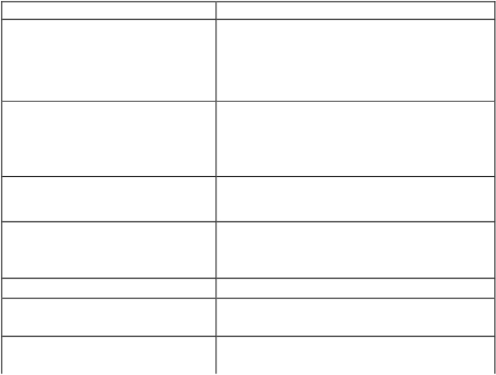

2. Disposition
1) DC Reactors Disposition

Connection: (1) Remove the jumpers of P and P1 terminals.
(2) Connect DC reactor to Terminals P and P1 as shown in the following
diagram:

Note: RLP inverter of above 37KW has connectors. The inverter of below 37KW must
not be connected with it.
The function of DC reactor is to restrict the AC component stacked with DC reactor to
a specified value to suppress the mains harmonics and improve the power factor of the
inverter.
2) AC Reactors Disposition
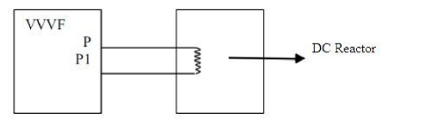

Inverter Model | Matched Power (W) | Rated Current(A) | Inductance (mH)
DCL-37 | 37 | 100 | 0.7
DCL-45 | 45 | 120 | 0.58
DCL-55 | 55 | 146 | 0.47
DCL-75 | 75 | 200 | 0.35
DCL-90 | 90 | 238 | 0.29
DCL-110 | 110 | 291 | 0.24
DCL-132 | 132 | 326 | 0.215
DCL-160 | 160 | 395 | 0177
DCL-200 | 200 | 494 | 0142
DCL-220 | 220 | 557 | 0126
DCL-280 | 280 | 700 | 010
DCL-300 | 300 | 800 | 0.08
DCL-315 | 315 | 800 | 0.08
DCL-345 | 345 | 660 | 0.07
DCL-375 | 375 | 715 | 0.064
DCL-400 | 400 | 765 | 0.058
DCL-415 | 415 | 795 | 0.053

Inverter Model Matched Power
Rated Current(A) Inductance (mH)
(W)
HKSG2-24 11 24 0.52
HKSG2-34 15 34 0.397
HKSG2-38 18.5 38 0.352
HKSG2-50 | 22 | 50 | 0.26
HKSG2-60 | 30 | 60 | 0.24

The incoming reactor is also named shift-changing reactor and it is used for the
incoming wire of the mains with AC flowing inside. Its function is to suppress the
harmonics of the inverter feedback to the mains.
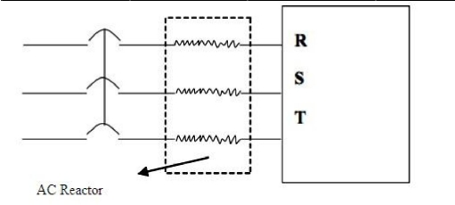

HKSG2-75 | 37 | 75 | 0.235
HKSG2-91 | 45 | 91 | 017
HKSG2-112 | 55 | 112 | 016
HKSG2-150 | 75 | 150 | 0112
HKSG2-180 | 90 | 180 | 010
HKSG2-220 | 110 | 220 | 0.09
HKSG2-265 | 132 | 265 | 0.08
HKSG2-300 | 160 | 300 | 0.07
HKSG2-360 | 200 (185) | 360 | 0.06
HKSG2-400 | 220 | 400 | 0.05
HKSG2-560 | 280 | 560 | 0.03
HKSG2-640 | 315 | 640 | 0.0215
HKSG2-700 | 345 | 700 | 0.019
HKSG2-750 | 375 | 750 | 0.017
HKSG2-800 | 400 | 800 | 0.015
HKSG2-860 | 415 | 860 | 0.012

Inverter Model | Braking resistor specification |  | Braking torque  10%ED | Special Motor  KW
Inverter Model | W |  | Braking torque  10%ED | Special Motor  KW
RLPA00D423B | 80 | 200 | 125 | 0.4
RLPA0D7523B | 100 | 200 | 125 | 0.75
RLPA01D523B | 300 | 100 | 125 | 1.5
RLPA02D223B | 300 | 70 | 125 | 2.2
RLPA0D7543B | 80 | 750 | 125 | 0.75
RLPA01D543B | 300 | 400 | 125 | 1.5
RLPA02D243B | 300 | 250 | 125 | 2.2
RLPA03D743B | 400 | 150 | 125 | 3.7
RLPA05D543B | 500 | 100 | 125 | 5.5
RLPA07D543B | 1000 | 75 | 125 | 75
RLPA001143B | 1000 | 50 | 125 | 11

For the braking resistor used for the machines of above 315 KW,

please contact the factory.

For the inverter of above 11KW to realize quick brake, a braking unit must be added.
Note: 1: Please select the resistor value and operating frequency given by our
company.
2: If it causes any damage to the inverter and other devices due to the use of any
braking resistor and braking model group not supplied by our company, we
will take no responsibility.
3: Be sure to consider the safety and ignitability of the environment when
installing a braking resistor. The distance to the inverter should be at least
100 mm.
4: If it is necessary to change the resistor value and power value, please contact
the local distributor.
5: In need of a braking resistor a separate order must be placed. Please contact
the local distributor for details.
RLPA001543B | 1500 | 40 | 125 | 15
RLPA18D543B | 4800 | 32 | 125 | 18.5
RLPA002243B | 4800 | 272 | 125 | 22
RLPA003043B | 6000 | 20 | 125 | 30
RLPA003743B | 9600 | 16 | 125 | 37
RLPA004543B | 9600 | 13.6 | 125 | 45
RLPA005543B | 12000 | 20/2 | 125 | 55
RLPA007543B | 18000 | 13.6/2 | 125 | 75
RLPA009043B | 18000 | 20/3 | 125 | 90
RLPA011043B | 18000 | 20/3 | 125 | 110
RLPA013243B | 24000 | 20/4 | 125 | 132
RLPA016043B | 36000 | 13.6/4 | 125 | 160
RLPA018543B | 45000 | 13.6/5 | 125 | 185
RLPA020043B | 45000 | 13.6/5 | 125 | 200
RLPA022043B | 48000 | 13.6/5 | 125 | 220
RLPA025043B | 48000 | 13.6/5 | 125 | 250
RLPA028043B | 57600 | 13.6/6 | 125 | 280
RLPA030043B | 57600 | 13.6/6 | 125 | 300

XII. Appendices

Appendix 1: Simple Examples of Application
1. Disturbance Function (Generation of Triangle Wave)

2. Drawing Function

Parameter setting:
Pd081=4 Pd003=25 Pd086=50 Pd087=30
Pd101=720 Pd046=29 Pd001=1
Note: (1) When triggered by external multi-function terminals (as RST in the
diagram), the drawing action starts to be implemented.
(2) In implementation of drawing action the running time T=P101*10S

3. FOR/REV Rotation of the Motor Controlled by One Potentiometer
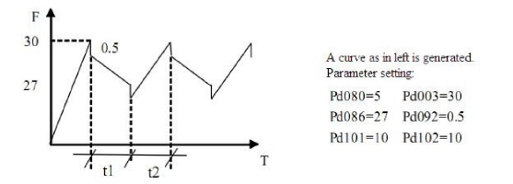

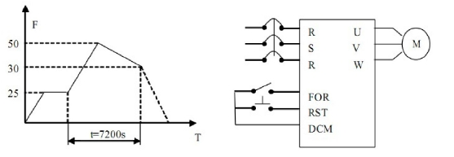

4. Internal Control 8 Speed Run
A curve as shown in the following diagram is established. Internal control 8-speed run
will stop after running for one cycle.

Note: 1.The running time of each speed is set by Pd101-Pd108=15;
2. Auto cycling Pd081=1;
3. After the running command is given, it will run with the set curve for one
cycle and stop.

5. Simple Water Supply with Constant Pressure
① Use a pressure transmitter with measuring range of 0-10kg, feedback of 4-20mA,
requiring water supply at the pressure of 5kg with alarming at the upper limit of 6kg
and the lower limit of 4kg. The start from the panel stops.
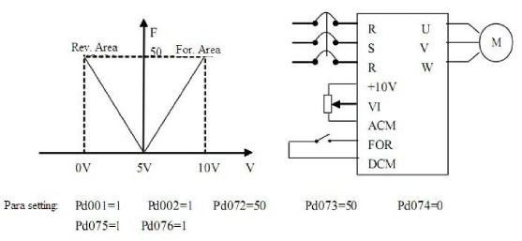

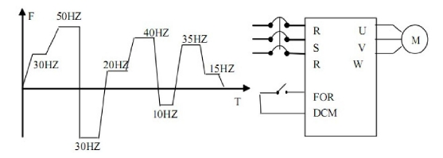

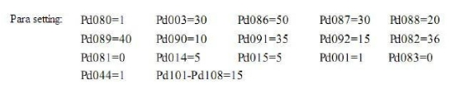

Note: Pd156, Pd157 and Pd158 should be set according to the actual conditions. For
general water supply with constant pressure, Pd150=80~100, Pd151=2.5~3, Pd152=0.

② For a resistance transmission pressure gauge of 0~10kg, it is required to control
operation and stop by external terminals and give a target value through a
potentiometer.
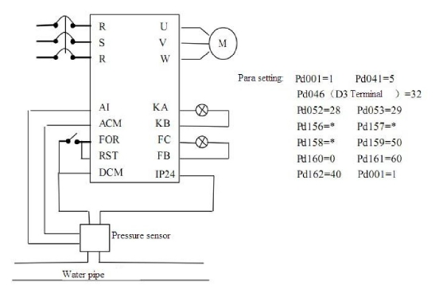

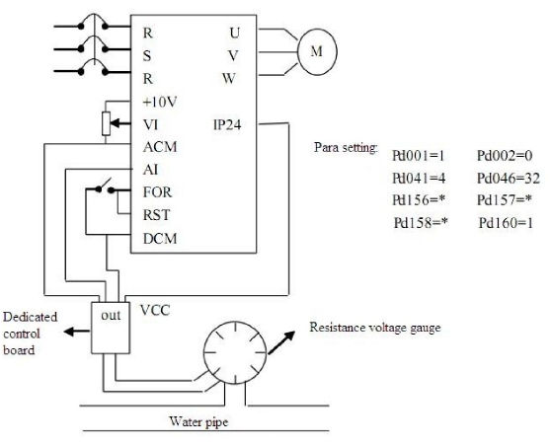

Attention:
(1) The target value of RLP series inverter can be selected in two ways, one is
to set it on the panel and another is the analog of 0~10V;
(2) The feedback signal is 4-20mA. Others are invalid;
(3) In this example the target value is given by the potentiometer (0~10V) ;
(4) Pd156, Pd157 and Pd158 should be set according the actual condition.
(Refer to the parameter description.)
(5) The special panel for PID is designed according to general resistance
transmission pressure gauge with input internal resistance converting to
the standard signal in 0-400Q. When the resistance value of the resistance
transmission pressure gauge used by the customer exceeds the specified
range, please change the resistance transmission pressure gauge or
connect a resistor in parallel for correction.
(6) Output resistance values vary with different manufacturers of resistance
transmission pressure gauge. After conversion, the levels of current signal
are different. The user can set a target value consistent with its actual
conditions by themselves.
(7) The target value is given by the potentiometer. Pd002 must be set as 1,
otherwise PID will not work.

6. Example common application of analog and multi-speed:
Requirement: Speed 1 is given frequency by analog. Use a switch to switch it and turn
to external control multi-speed run.

Action Description: (1)

(2) The switching of forward and reverse rotation can be implemented through either
multi-function terminals or the FOR/REV key on the panel. (In this example, the
switching is made through the panel)

7. Example application of Auto PLC Suspend
Requirement: Auto PLC can be suspended during the internal control multi-speed run.
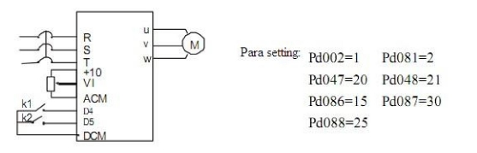

K1 State | K2 State | Operating Frequency
OFF | OFF | Given by a potentiometer
ON | OFF | Speed 2 ( 15Hz )
OFF | ON | Speed 3 ( 30Hz )
ON | ON | Speed 4 ( 25Hz )

After handling the related problems, it can resume.
(1) Connection

(2). Parameters: Pd001=1 D1 terminal control operation
Pd049=31 SPL terminal is set for Auto PLC reset suspend function.
Pd117=1 Auto PLC Memory
Pd081=1 Cycling run
Pd080=1 Internal control multi-speed
Pd086=15 Pd088=20 Pd086=25 Pd003=10
Pd101=10 Pd102=10 Pd103=10 Pd104=10
(3) Operating curve:

(4) Operation description
① (K1) D1 is closed and the inverter will run according to the program set by
internal control multi-speeds.
②When it is required to stop due to fault and process or other reasons, K1 will be
opened. And the inverter will stop output and suspend counting time. After the
fault is removed, K1 will be closed and the inverter will continue to run according
to original program.
③ When it is required to run again from the beginning due to fault and process stop,
K1 should be opened. Press K2 to reset. By closing K1, it will restart to run.
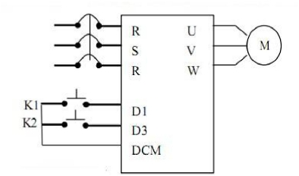

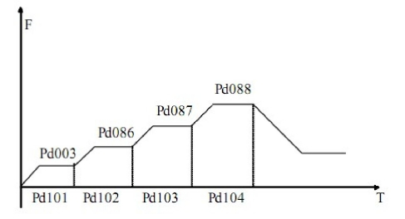

8. Application example of plastic injection machine
Control principle diagram

Note: Places marked with ‘*” are to be decided upon the concrete conditions.
When the inverter is under operation, please do not shift the switch. When it has
to be shifted, make sure the inverter stops the output.
